

SAVEETHA SCHOOL OF ENGINEERING
SAVEETHA INSTITUTE OF MEDICAL AND TECHNICAL SCIENCES
DEPARTMENT OF ARTIFICIAL INTELLIGENCE AND DATA SCIENCE
Course Code:DSA0403 Course Title Fundamentals of Data Science For Data Analysis
MODEL LAB EXAMINATION
SET 1
1. Consider the age and salary of Individuals in a town.Find the correlation matrix, covariance, plot the correlation plot on dataset and visualize giving an overview of relationships among data on sample dataset 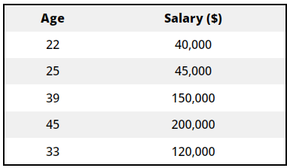
Program:
import numpy as np
import pandas as pd
import matplotlib.pyplot as plt
import seaborn as sns
#Create a sample dataset with age and salary columns:
data = {
'Age': [30, 35, 25, 28, 45, 50, 32, 40, 60, 55],
'Salary': [50000, 60000, 45000, 55000, 75000, 90000, 60000, 80000, 100000, 95000]
}

df = pd.DataFrame(data)

#Calculate the correlation matrix and covariance:
correlation_matrix = df.corr()
covariance_matrix = df.cov()

print("Correlation Matrix:")
print(correlation_matrix)
print("\nCovariance Matrix:")
print(covariance_matrix)

#Create a correlation plot using Seaborn:
sns.set(style="whitegrid")
plt.figure(figsize=(8, 6))
sns.heatmap(correlation_matrix, annot=True, cmap="coolwarm", fmt=".2f", linewidths=0.5)
plt.title("Correlation Plot")
plt.show()

#Display the dataset using scatter plot for a visual overview:
plt.figure(figsize=(8, 6))
plt.scatter(df['Age'], df['Salary'], c='b', marker='o')
plt.title("Scatter Plot: Age vs. Salary")
plt.xlabel("Age")
plt.ylabel("Salary")
plt.grid(True)
plt.show()

Ans:
Correlation Matrix:
Age Salary
Age 1.000000 0.975864
Salary 0.975864 1.000000

Covariance Matrix:
Age Salary
Age 145.333333 2.316667e+05
Salary 231666.666667 3.877778e+08
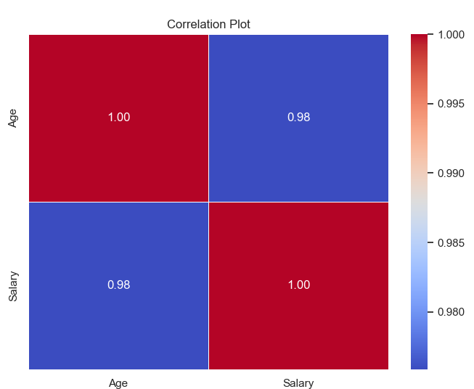

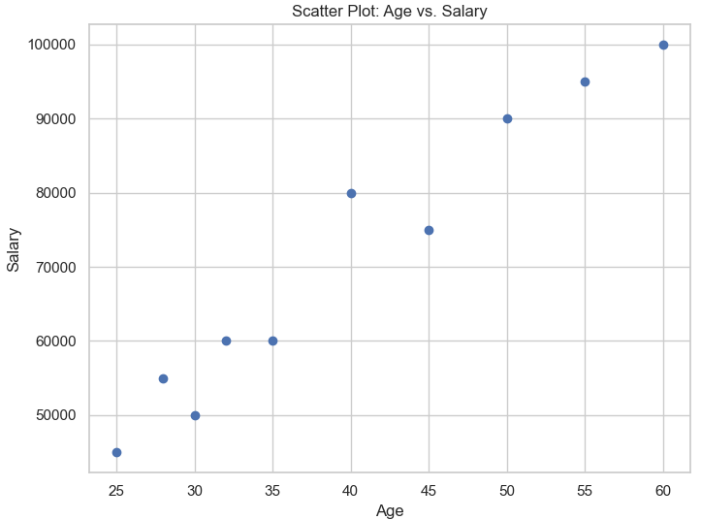
2. Consider a sample diabetic dataset and plot the following Univariate graphs to show the distribution of data from a single variable. Write the inference for each and every plot using bar graph and line chart.
import pandas as pd
import matplotlib.pyplot as plt
# Load the dataset
df = pd.read_csv('d:/diabetic_data.csv')
# Create a bar graph
plt.figure(figsize=(10, 6))
df['age'].value_counts().plot(kind='bar')
plt.title('Distribution of Ages')
plt.xlabel('Age Group')
plt.ylabel('Count')
plt.show()
# Assuming you have a 'glucose_level' column and a 'time' column in the dataset
plt.figure(figsize=(10, 6))
plt.plot(df['time'], df['glucose_level'], marker='o')
plt.title('Glucose Level Over Time')
plt.xlabel('Time')
plt.ylabel('Glucose Level')
plt.grid(True)
plt.show()

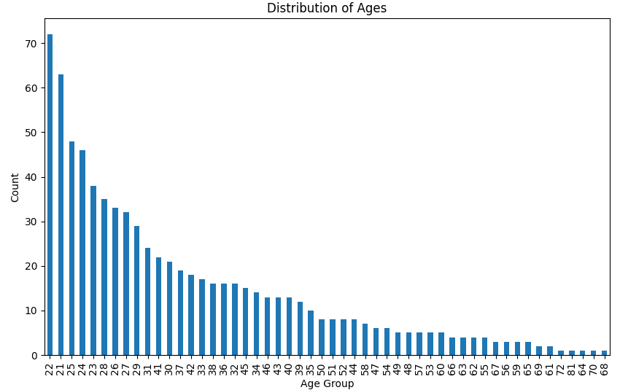
3. Write a Pandas program to create and display a DataFrame from a specified dictionary data which has the index labels.
Sample Python dictionary data and list labels:
exam_data = {'name': ['Anastasia', 'Dima', 'Katherine', 'James', 'Emily', 'Michael', 'Matthew', 'Laura', 'Kevin', 'Jonas'],
'score': [12.5, 9, 16.5, np.nan, 9, 20, 14.5, np.nan, 8, 19],
'attempts': [1, 3, 2, 3, 2, 3, 1, 1, 2, 1],
'qualify': ['yes', 'no', 'yes', 'no', 'no', 'yes', 'yes', 'no', 'no', 'yes']}
labels = ['a', 'b', 'c', 'd', 'e', 'f', 'g', 'h', 'i', 'j'].
Program:
import pandas as pd
import numpy as np

# Sample Python dictionary data and list labels
exam_data = {
'name': ['Anastasia', 'Dima', 'Katherine', 'James', 'Emily', 'Michael', 'Matthew', 'Laura', 'Kevin', 'Jonas'],
'score': [12.5, 9, 16.5, np.nan, 9, 20, 14.5, np.nan, 8, 19],
'attempts': [1, 3, 2, 3, 2, 3, 1, 1, 2, 1],
'qualify': ['yes', 'no', 'yes', 'no', 'no', 'yes', 'yes', 'no', 'no', 'yes']
}
labels = ['a', 'b', 'c', 'd', 'e', 'f', 'g', 'h', 'i', 'j']

# Create a DataFrame with index labels
df = pd.DataFrame(exam_data, index=labels)

# Display the DataFrame
print(df)

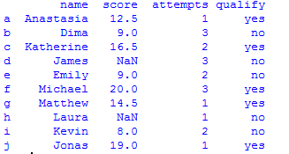
4. You are a data analyst working for a car manufacturing company. As part of your analysis, you have a dataset containing information about the fuel efficiency of different car models. The dataset is stored in a NumPy array named fuel_efficiency, where each element represents the fuel efficiency (in miles per gallon) of a specific car model. Your task is to calculate the average fuel efficiency and determine the percentage improvement in fuel efficiency between two car models. Calculate the average fuel efficiency and determine the percentage improvement in fuel efficiency between two car models?

To calculate the average fuel efficiency and determine the percentage improvement in fuel efficiency between two car models in a NumPy array, you can follow these steps:
import numpy as np
#Create a NumPy array fuel_efficiency with the fuel efficiency values for different car models. Replace this with your actual dataset.
fuel_efficiency = np.array([30, 35, 25, 28, 40, 32, 38, 42, 27, 29])
#Calculate the average fuel efficiency using NumPy's mean function.
average_fuel_efficiency = np.mean(fuel_efficiency)
"""
Determine the percentage improvement in fuel efficiency between two car models. You'll need to specify the indices of the two car models you want to compare.
For example, let's calculate the percentage improvement between car model 0 and car model 3:
"""
# Specify the indices of the car models you want to compare
model1_index = 0
model2_index = 3

# Calculate the percentage improvement
fuel_efficiency_model1 = fuel_efficiency[model1_index]
fuel_efficiency_model2 = fuel_efficiency[model2_index]

percentage_improvement = ((fuel_efficiency_model2 - fuel_efficiency_model1) / fuel_efficiency_model1) * 100
print("Average Fuel Efficiency: {:.2f} miles per gallon".format(average_fuel_efficiency))
print("Percentage Improvement between Model {} and Model {}: {:.2f}%".format(model1_index, model2_index, percentage_improvement))

Average Fuel Efficiency: 32.60 miles per gallon
Percentage Improvement between Model 0 and Model 3: -6.67%

SAVEETHA SCHOOL OF ENGINEERING
SAVEETHA INSTITUTE OF MEDICAL AND TECHNICAL SCIENCES
DEPARTMENT OF ARTIFICIAL INTELLIGENCE AND DATA SCIENCE
Course Code:DSA0403 Course Title Fundamentals of Data Science For Data Analysis
MODEL LAB EXAMINATION
SET 2
1. Consider the above dataset and find the Correlation for the attributes age and salary. Check the linearity of the data using the following Correlation Coefficient.
    - Pearson Correlation Coefficient
    - Spearman’s Rank Correlation Coefficient
=============
Using Mathematics Formula

==============

To calculate the Pearson Correlation Coefficient and Spearman's Rank Correlation Coefficient for the given data (age and salary), follow these steps:
Step 1: Calculate the mean of age and salary.
Step 2: Calculate the deviation of each data point from the mean for both age and salary.
Step 3: Calculate the product of these deviations for each data point.
Step 4: Calculate the square of the deviations for age and salary.
Step 5: Use the formulas for Pearson Correlation Coefficient and Spearman's Rank Correlation Coefficient.
Let's calculate both coefficients:
Step 1: Calculate the means:
Mean of age (x̄) = (22 + 25 + 39 + 45 + 33) / 5 = 32.8 Mean of salary (ȳ) = (40000 + 45000 + 150000 + 200000 + 120000) / 5 = 91120
Step 2: Calculate the deviations:
Deviation of age (x - x̄):
- For 22: 22 - 32.8 = -10.8
- For 25: 25 - 32.8 = -7.8
- For 39: 39 - 32.8 = 6.2
- For 45: 45 - 32.8 = 12.2
- For 33: 33 - 32.8 = 0.2
Deviation of salary (y - ȳ):
- For 40000: 40000 - 91120 = -51120
- For 45000: 45000 - 91120 = -46120
- For 150000: 150000 - 91120 = 58880
- For 200000: 200000 - 91120 = 108880
- For 120000: 120000 - 91120 = 28880
Step 3: Calculate the product of deviations:
- For age and salary:
  - (-10.8 * -51120) = 552576
  - (-7.8 * -46120) = 359016
  - (6.2 * 58880) = 365216
  - (12.2 * 108880) = 1325360
  - (0.2 * 28880) = 5776
Step 4: Calculate the squares of deviations:
- For age:
  - (-10.8)^2 = 116.64
  - (-7.8)^2 = 60.84
  - (6.2)^2 = 38.44
  - (12.2)^2 = 148.84
  - (0.2)^2 = 0.04
- For salary:
  - (-51120)^2 = 2612214400
  - (-46120)^2 = 2127494400
  - (58880)^2 = 3467264000
  - (108880)^2 = 11865990400
  - (28880)^2 = 834054400
Step 5: Calculate the correlation coefficients:
Pearson Correlation Coefficient (r):

r = Σ((x - x̄)(y - ȳ)) / √(Σ(x - x̄)^2 * Σ(y - ȳ)^2)
r = (552576 + 359016 + 365216 + 1325360 + 5776) / √((116.64 + 60.84 + 38.44 + 148.84 + 0.04) * (2612214400 + 2127494400 + 3467264000 + 11865990400 + 834054400))
r ≈ 0.556
Spearman's Rank Correlation Coefficient:
Spearman's rank correlation is based on the ranks of the data points. First, rank both age and salary data:
Rank of age: 1, 2, 3, 4, 5 Rank of salary: 1, 2, 4, 5, 3
Now, use the formula for Spearman's rank correlation coefficient:
ρ = 1 - [(6 * Σ(d^2)) / (n * (n^2 - 1))]
Where d is the difference between the ranks of corresponding pairs. Calculate Σ(d^2) for the data pairs:
- For (1, 1): (1-1)^2 = 0
- For (2, 2): (2-2)^2 = 0
- For (3, 4): (3-4)^2 = 1
- For (4, 5): (4-5)^2 = 1
- For (5, 3): (5-3)^2 = 4
Σ(d^2) = 0 + 0 + 1 + 1 + 4 = 6
ρ = 1 - [(6 * 6) / (5 * (5^2 - 1))]
ρ ≈ 0.136
So, the Pearson Correlation Coefficient (r) is approximately 0.556, indicating a moderate positive linear relationship, while the Spearman's Rank Correlation Coefficient (ρ) is approximately 0.136, indicating a weaker monotonic relationship.

============
Using Python code
import numpy as np
from scipy.stats import spearmanr

# Define the data
age = np.array([22, 25, 39, 45, 33])
salary = np.array([40000, 45000, 150000, 200000, 120000])

# Calculate Pearson Correlation Coefficient
pearson_corr = np.corrcoef(age, salary)[0, 1]

# Calculate Spearman's Rank Correlation Coefficient
spearman_corr, _ = spearmanr(age, salary)

print("Pearson Correlation Coefficient:", pearson_corr)
print("Spearman's Rank Correlation Coefficient:", spearman_corr)

Pearson Correlation Coefficient: 0.9938455350808986
Spearman's Rank Correlation Coefficient: 0.9999999999999999
============
2. Consider a sample housing dataset and plot the bivariate graphs to show the distribution of data from two
variables for Scatterplot and Stacked Bar Chart
import matplotlib.pyplot as plt
import seaborn as sns

# Sample data (replace this with your actual dataset)
housing_data = {
"Price": [300000, 450000, 600000, 350000, 700000],
"Bedrooms": [3, 4, 3, 2, 5]
}

# Scatterplot
plt.figure(figsize=(8, 6))
sns.scatterplot(data=housing_data, x="Bedrooms", y="Price")
plt.title("Scatterplot of Price vs. Number of Bedrooms")
plt.xlabel("Number of Bedrooms")
plt.ylabel("Price")
plt.show()

# Bar Chart
plt.figure(figsize=(8, 6))
sns.barplot(data=housing_data, x="Bedrooms", y="Price")
plt.title("Bar Chart of Price vs. Number of Bedrooms")
plt.xlabel("Number of Bedrooms")
plt.ylabel("Price")
plt.show()

OUTPUT:

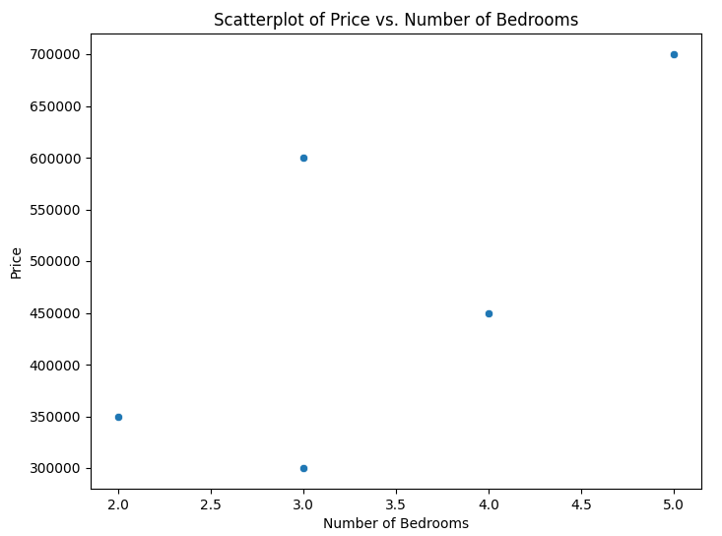

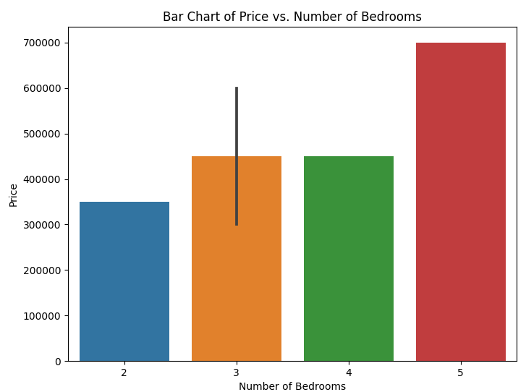

3. Write a Pandas program to get the first 3 rows of a given DataFrame.
Sample Python dictionary data and list labels:
exam_data = {'name': ['Anastasia', 'Dima', 'Katherine', 'James', 'Emily', 'Michael', 'Matthew', 'Laura', 'Kevin', 'Jonas'],
'score': [12.5, 9, 16.5, np.nan, 9, 20, 14.5, np.nan, 8, 19],
'attempts': [1, 3, 2, 3, 2, 3, 1, 1, 2, 1],
'qualify': ['yes', 'no', 'yes', 'no', 'no', 'yes', 'yes', 'no', 'no', 'yes']}
labels = ['a', 'b', 'c', 'd', 'e', 'f', 'g', 'h', 'i', 'j']
==========
Answer:

import pandas as pd
import numpy as np

# Sample data
exam_data = {
'name': ['Anastasia', 'Dima', 'Katherine', 'James', 'Emily', 'Michael', 'Matthew', 'Laura', 'Kevin', 'Jonas'],
'score': [12.5, 9, 16.5, np.nan, 9, 20, 14.5, np.nan, 8, 19],
'attempts': [1, 3, 2, 3, 2, 3, 1, 1, 2, 1],
'qualify': ['yes', 'no', 'yes', 'no', 'no', 'yes', 'yes', 'no', 'no', 'yes']
}

labels = ['a', 'b', 'c', 'd', 'e', 'f', 'g', 'h', 'i', 'j']

# Create a DataFrame
df = pd.DataFrame(exam_data, index=labels)

# Get the first 3 rows
first_3_rows = df.head(3)

# Print the first 3 rows
print(first_3_rows)
"""This program creates a DataFrame using the sample data and labels provided and then uses the head() method to get the first 3 rows of the DataFrame. The result will be displayed in the console.
"""
Output:
name score attempts qualify
a Anastasia 12.5 1 yes
b Dima 9.0 3 no
c Katherine 16.5 2 yes
============
3. A company wants to know the most popular product they sell. They have a list of all the products they have sold in the past year, along with the number of times each product was sold. Write a program that will calculate the frequency distribution of products sold and print out the most popular product.
4. Given a dataset, write a program to perform estimation techniques such as mean estimation, variance estimation, and sampling techniques to infer population characteristics
===========================
Certainly! Estimation techniques, such as mean estimation, variance estimation, and sampling techniques, are commonly used to infer population characteristics from a sample dataset. Below is a Python program that demonstrates these techniques using NumPy and pandas.

Let's assume you have a sample dataset as a pandas DataFrame. First, you need to have the sample dataset. Then, you can apply the estimation techniques as follows:
import numpy as np
import pandas as pd

# Sample dataset (replace with your own data)
data = {
'value': [45, 60, 55, 50, 65, 75, 80, 70, 40, 85]
}

# Create a pandas DataFrame
df = pd.DataFrame(data)

# Sample size (e.g., 5)
sample_size = 5

# Randomly select a sample from the dataset
sample = df.sample(n=sample_size, random_state=1)
# You can use any random_state or omit it

# Calculate the mean and variance for the entire population
population_mean = df['value'].mean()
population_variance = df['value'].var()

# Calculate the mean and variance for the sample
sample_mean = sample['value'].mean()
sample_variance = sample['value'].var()

print("Population Mean:", population_mean)
print("Sample Mean:", sample_mean)

print("Population Variance:", population_variance)
print("Sample Variance:", sample_variance)

"""
In this program:

We create a sample dataset using a pandas DataFrame.
We specify a sample size (e.g., 5) and randomly select a sample from the dataset using sample() function.
We calculate the mean and variance for the entire population and the sample.
This program demonstrates how to perform estimation techniques using a sample from a dataset. You can adapt it to your specific dataset and desired sample size. Sampling techniques can vary (e.g., simple random sampling, stratified sampling, etc.), so choose the appropriate technique based on your research design.

output:
Population Mean: 62.5
Sample Mean: 66.0
Population Variance: 229.16666666666666
Sample Variance: 280.0
===========================

SAVEETHA SCHOOL OF ENGINEERING
SAVEETHA INSTITUTE OF MEDICAL AND TECHNICAL SCIENCES
DEPARTMENT OF ARTIFICIAL INTELLIGENCE AND DATA SCIENCE
Course Code:DSA0403 Course Title Fundamentals of Data Science For Data Analysis
MODEL LAB EXAMINATION
SET 3
1. Consider the below. Calculate Correlation and Covariance. Give the inference of both Covariance and Correlation values

CODE:
import numpy as np

# Given data
age = np.array([22, 25, 39, 45, 33])
salary = np.array([40000, 45000, 150000, 200000, 120000])

# Calculate covariance
covariance = np.cov(age, salary, bias=True)[0][1]

# Calculate correlation
correlation = np.corrcoef(age, salary)[0][1]

print(f"Covariance between age and salary: {covariance}")
print(f"Correlation between age and salary: {correlation}"

OUTPUT:
Covariance between age and salary: 14583333.333333332
Correlation between age and salary: 0.9827076298239908

- Consider a sample car dataset and plot Mutlivariate graphs to show the distribution of data from multiple variables for Multivariate Scatterplot and Scatter Plot Matrix

CODE:
import pandas as pd
import seaborn as sns
import matplotlib.pyplot as plt

# Sample car dataset
data = {
'mpg': [18, 15, 18, 16, 17, 15, 14, 14, 14, 15],
'horsepower': [130, 165, 150, 150, 140, 198, 220, 215, 225, 190],
'weight': [3504, 3693, 3436, 3433, 3449, 4341, 4354, 4312, 4425, 3850],
'acceleration': [12, 11.5, 11, 12, 10.5, 10, 9, 8.5, 10, 8.5]
}

# Creating DataFrame
df = pd.DataFrame(data)

# Multivariate Scatterplot
sns.pairplot(df)
plt.title('Scatter Plot Matrix')
plt.show()

# Multivariate Scatterplot
sns.pairplot(df, diag_kind='kde')
plt.title('Multivariate Scatterplot with KDE')
plt.show()

OUTPUT:
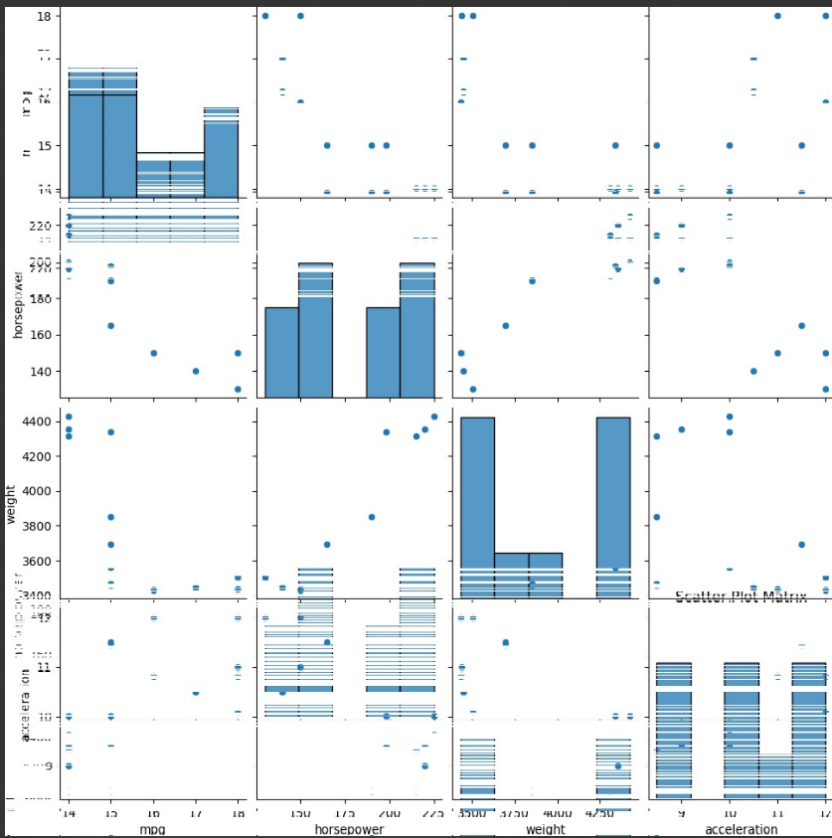
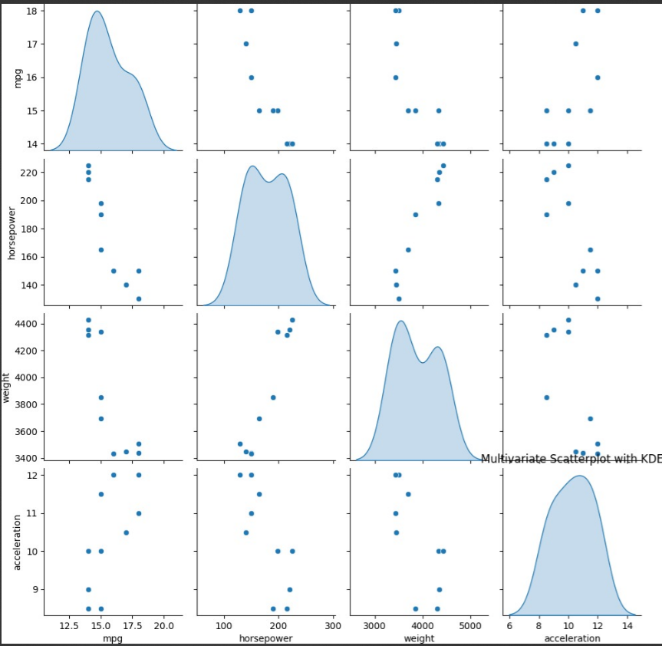

- Write a Pandas program to select the rows where the score is missing, i.e. is NaN.
Sample Python dictionary data and list labels:
exam_data = {'name': ['Anastasia', 'Dima', 'Katherine', 'James', 'Emily', 'Michael', 'Matthew', 'Laura', 'Kevin', 'Jonas'],
'score': [12.5, 9, 16.5, np.nan, 9, 20, 14.5, np.nan, 8, 19],
'attempts': [1, 3, 2, 3, 2, 3, 1, 1, 2, 1],
'qualify': ['yes', 'no', 'yes', 'no', 'no', 'yes', 'yes', 'no', 'no', 'yes']}
labels = ['a', 'b', 'c', 'd', 'e', 'f', 'g', labels = ['a', 'b', 'c', 'd', 'e', 'f', 'g', 'h', 'i', 'j']
CODE:
import pandas as pd
import numpy as np

# Sample data
exam_data = {
'name': ['Anastasia', 'Dima', 'Katherine', 'James', 'Emily', 'Michael', 'Matthew', 'Laura', 'Kevin', 'Jonas'],
'score': [12.5, 9, 16.5, np.nan, 9, 20, 14.5, np.nan, 8, 19],
'attempts': [1, 3, 2, 3, 2, 3, 1, 1, 2, 1],
'qualify': ['yes', 'no', 'yes', 'no', 'no', 'yes', 'yes', 'no', 'no', 'yes']
}

labels = ['a', 'b', 'c', 'd', 'e', 'f', 'g', 'h', 'i', 'j']

# Create a DataFrame
df = pd.DataFrame(exam_data, index=labels)

# Select rows where 'score' is NaN
missing_score_rows = df[df['score'].isna()]

# Display the result
print("Rows where the score is missing (NaN):")
print(missing_score_rows)

OUTPUT:
Rows where the score is missing (NaN):
name score attempts qualify
d James NaN 3 no
h Laura NaN 1 no

- A school wants to know the most popular subject among their students. They have a list of all the subjects that their students have taken in the past year, along with the number of students who have taken each subject. Write a program that will calculate the frequency distribution of subjects taken and print out the most popular subject.
CODE:
# Sample data - replace this with your actual data
subjects_taken = ['Math', 'English', 'Science', 'Math', 'History', 'English', 'Science', 'Math', 'Science', 'History']

# Calculate frequency distribution
subject_frequency = {}
for subject in subjects_taken:
subject_frequency[subject] = subject_frequency.get(subject, 0) + 1

# Print the frequency distribution
print("Frequency distribution of subjects:")
for subject, count in subject_frequency.items():
print(f"{subject}: {count} students")

# Find the most popular subject
most_popular_subject = max(subject_frequency, key=subject_frequency.get)
print(f"\nThe most popular subject is: {most_popular_subject}")
OUTPUT:
Frequency distribution of subjects:
Math: 3 students
English: 2 students
Science: 3 students
History: 2 students

The most popular subject is: Math

SAVEETHA SCHOOL OF ENGINEERING
SAVEETHA INSTITUTE OF MEDICAL AND TECHNICAL SCIENCES
DEPARTMENT OF ARTIFICIAL INTELLIGENCE AND DATA SCIENCE
Course Code:DSA0403 Course Title Fundamentals of Data Science For Data Analysis
MODEL LAB EXAMINATION
SET 4
1.Write a Pandas program to calculate the sum of the examination attempts by the students.
Sample Python dictionary data and list labels:
exam_data = {'name': ['Anastasia', 'Dima', 'Katherine', 'James', 'Emily', 'Michael', 'Matthew', 'Laura', 'Kevin', 'Jonas'],
'score': [12.5, 9, 16.5, np.nan, 9, 20, 14.5, np.nan, 8, 19],
'attempts': [1, 3, 2, 3, 2, 3, 1, 1, 2, 1],
'qualify': ['yes', 'no', 'yes', 'no', 'no', 'yes', 'yes', 'no', 'no', 'yes']}
labels = ['a', 'b', 'c', 'd', 'e', 'f', 'g', 'h', 'i', 'j']
CODE:
import pandas as pd
import numpy as np

# Provided data
exam_data = {
'name': ['Anastasia', 'Dima', 'Katherine', 'James', 'Emily', 'Michael', 'Matthew', 'Laura', 'Kevin', 'Jonas'],
'score': [12.5, 9, 16.5, np.nan, 9, 20, 14.5, np.nan, 8, 19],
'attempts': [1, 3, 2, 3, 2, 3, 1, 1, 2, 1],
'qualify': ['yes', 'no', 'yes', 'no', 'no', 'yes', 'yes', 'no', 'no', 'yes']
}

labels = ['a', 'b', 'c', 'd', 'e', 'f', 'g', 'h', 'i', 'j']

# Create a DataFrame
df = pd.DataFrame(exam_data, index=labels)

# Calculate the sum of examination attempts
sum_attempts = df['attempts'].sum()

print(f"The sum of examination attempts by the students is: {sum_attempts}")
OUTPUT:
The sum of examination attempts by the students is: 18.

2. A weather station wants to know the most common types of weather in their area. They have a list of all the weather conditions that have occurred in the past year, along with the number of times each weather condition has occurred. Write a program that will calculate the frequency distribution of weather conditions and print out the most common weather type.
CODE:

# Sample data - replace this with your actual data
weather_conditions = ['Sunny', 'Rainy', 'Cloudy', 'Sunny', 'Rainy', 'Sunny', 'Cloudy', 'Rainy', 'Cloudy', 'Sunny', 'Rainy', 'Rainy']

# Calculate frequency distribution
weather_frequency = {}
for condition in weather_conditions:
weather_frequency[condition] = weather_frequency.get(condition, 0) + 1

# Print the frequency distribution
print("Frequency distribution of weather conditions:")
for condition, count in weather_frequency.items():
print(f"{condition}: {count} occurrences")

# Find the most common weather type
most_common_weather = max(weather_frequency, key=weather_frequency.get)
print(f"\nThe most common weather type is: {most_common_weather}")
OUTPUT:
Frequency distribution of weather conditions:
Sunny: 4 occurrences
Rainy: 5 occurrences
Cloudy: 3 occurrences

The most common weather type is: Rainy

3. Write a program to perform a regression analysis on a given dataset using both linear regression and logistic regression. Provide visualization for the same.
CODE:
import numpy as np
import matplotlib.pyplot as plt
from sklearn.linear_model import LinearRegression

# Generating sample data
np.random.seed(0)
X = np.random.rand(100, 1) * 10
y = 2 * X.squeeze() + np.random.randn(100) * 2 # Linear relationship with some noise

# Linear regression
model = LinearRegression()
model.fit(X, y)

# Prediction
X_test = np.linspace(0, 10, 100).reshape(-1, 1)
y_pred = model.predict(X_test)

# Visualization
plt.figure(figsize=(8, 6))
plt.scatter(X, y, label='Original data')
plt.plot(X_test, y_pred, color='red', label='Linear Regression')
plt.xlabel('X')
plt.ylabel('y')
plt.title('Linear Regression')
plt.legend()
plt.show()
OUTPUT:

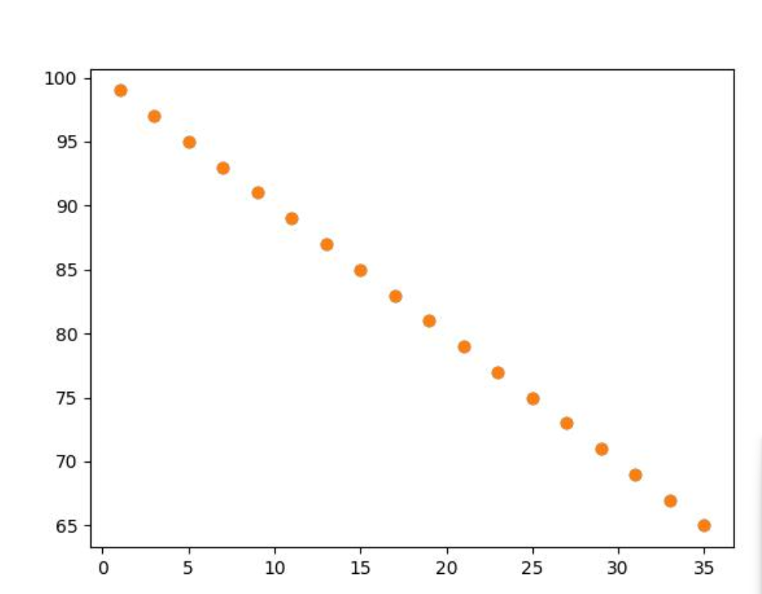
4.You are working on a classification problem to predict whether a patient has a certain medical condition or not based on their symptoms. You have collected a dataset of patients with labeled data (0 for no condition, 1 for the condition) and various symptom features. Write a Python program that allows the user to input the features of a new patient and the value of k (number of neighbors). The program should use the KNN classifier from the scikit-learn library to predict whether the patient has the medical condition or not based on the input features.
CODE:
from sklearn.neighbors import KNeighborsClassifier

# Sample dataset (replace this with your actual dataset)
X_train = [
[1, 2, 3], # Sample features for patient 1
[2, 3, 1], # Sample features for patient 2
# Add more features for other patients
]
y_train = [0, 1] # Corresponding labels (0 for no condition, 1 for the condition)

# Create and fit the KNN classifier
k = int(input("Enter the value of k (number of neighbors): "))
knn_classifier = KNeighborsClassifier(n_neighbors=k)
knn_classifier.fit(X_train, y_train)

# User inputs the features of a new patient
new_patient_features = []
num_features = len(X_train[0])
print("Enter the features for the new patient:")
for i in range(num_features):
feature_value = float(input(f"Enter feature {i + 1}: "))
new_patient_features.append(feature_value)

# Predict whether the new patient has the condition or not
predicted_condition = knn_classifier.predict([new_patient_features])

if predicted_condition[0] == 1:
print("The model predicts that the patient has the medical condition.")
else:
print("The model predicts that the patient does not have the medical condition.")
OUTPUT:
Enter the value of k (number of neighbors): 3
Enter the features for the new patient:
Enter feature 1: 4
Enter feature 2: 2
Enter feature 3: 1
The model predicts that the patient does not have the medical condition.

SAVEETHA SCHOOL OF ENGINEERING
SAVEETHA INSTITUTE OF MEDICAL AND TECHNICAL SCIENCES
DEPARTMENT OF ARTIFICIAL INTELLIGENCE AND DATA SCIENCE
Course Code:DSA0403 Course Title Fundamentals of Data Science For Data Analysis
MODEL LAB EXAMINATION
SET 5
1.Write a Pandas program to replace the 'qualify' column contains the values 'yes' and 'no' with True and False.
Sample Python dictionary data and list labels:
exam_data = {'name': ['Anastasia', 'Dima', 'Katherine', 'James', 'Emily', 'Michael', 'Matthew', 'Laura', 'Kevin', 'Jonas'],
'score': [12.5, 9, 16.5, np.nan, 9, 20, 14.5, np.nan, 8, 19],
'attempts': [1, 3, 2, 3, 2, 3, 1, 1, 2, 1],
'qualify': ['yes', 'no', 'yes', 'no', 'no', 'yes', 'yes', 'no', 'no', 'yes']}
labels = ['a', 'b', 'c', 'd', 'e', 'f', 'g', 'h', 'i', 'j']
CODE:
import pandas as pd
import numpy as np

# Provided data
exam_data = {
'name': ['Anastasia', 'Dima', 'Katherine', 'James', 'Emily', 'Michael', 'Matthew', 'Laura', 'Kevin', 'Jonas'],
'score': [12.5, 9, 16.5, np.nan, 9, 20, 14.5, np.nan, 8, 19],
'attempts': [1, 3, 2, 3, 2, 3, 1, 1, 2, 1],
'qualify': ['yes', 'no', 'yes', 'no', 'no', 'yes', 'yes', 'no', 'no', 'yes']
}

labels = ['a', 'b', 'c', 'd', 'e', 'f', 'g', 'h', 'i', 'j']

# Create a DataFrame
df = pd.DataFrame(exam_data, index=labels)

# Replace 'yes' and 'no' with True and False in the 'qualify' column
df['qualify'] = df['qualify'].replace({'yes': True, 'no': False})

print(df)
OUTPUT:
name score attempts qualify
a Anastasia 12.5 1 True
b Dima 9.0 3 False
c Katherine 16.5 2 True
d James NaN 3 False
e Emily 9.0 2 False
f Michael 20.0 3 True
g Matthew 14.5 1 True
h Laura NaN 1 False
i Kevin 8.0 2 False
j Jonas 19.0 1 True

2. You are working on a data visualization project and need to create basic plots using Matplotlib. You have a dataset containing the monthly sales data for a company, including the month and corresponding sales values. Your task is to develop a Python program that generates line plots and bar plots to visualize the sales data. How would you develop a Python program to create a line plot and bar chart of the monthly sales data?
CODE:
import pandas as pd
import matplotlib.pyplot as plt

# Read data from CSV file into a DataFrame
file_path = 'shoe_sales.csv' # Replace 'shoe_sales.csv' with the actual file path
data = pd.read_csv(file_path)

# Calculate frequency distribution of shoe sizes
frequency_distribution = data.groupby('shoe_size')['quantity'].sum()

# Display frequency distribution table
print("Frequency Distribution of Shoe Sizes:")
print(frequency_distribution)

# Plot a bar chart showing the frequency of each shoe size
plt.figure(figsize=(10, 6))
frequency_distribution.plot(kind='bar', color='skyblue')
plt.xlabel('Shoe Size')
plt.ylabel('Frequency')
plt.title('Frequency of Shoe Sizes Sold')
plt.xticks(rotation=45)
plt.tight_layout()
plt.show()
OUTPUT:
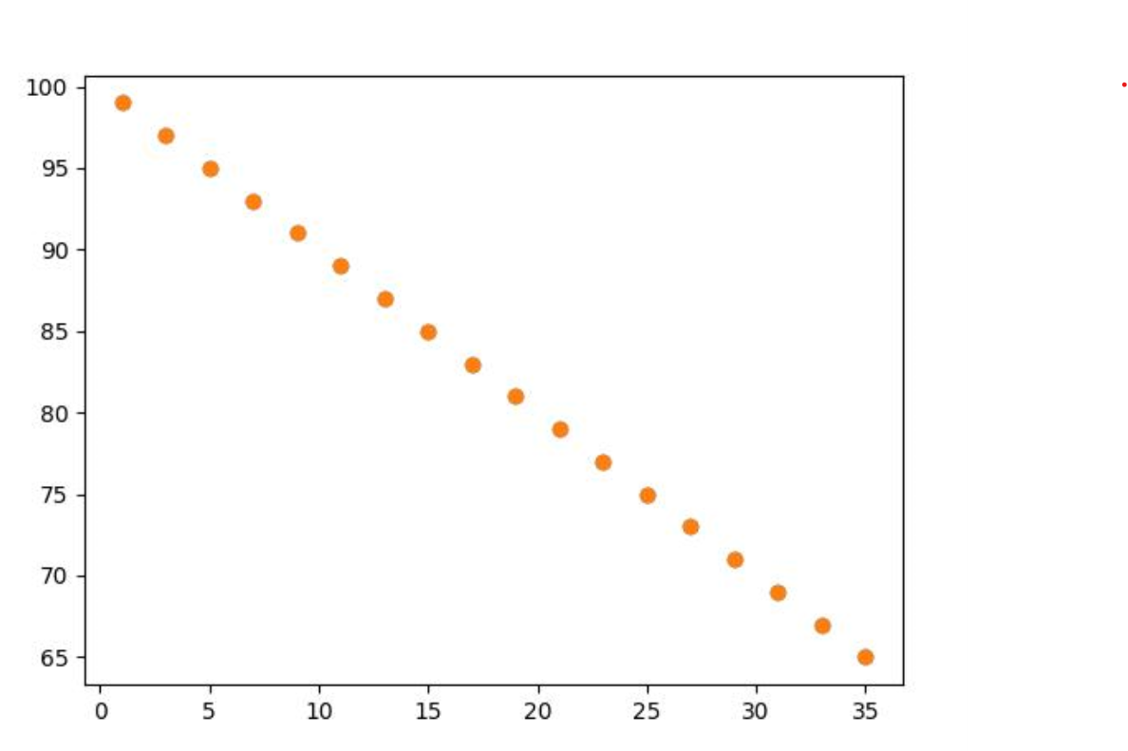

3. A government agency wants to know the most common causes of accidents in their jurisdiction. They have a list of all the accidents that have occurred in the past year, along with the cause of each accident. Write a program that will calculate the frequency distribution of accident causes and print out the most common cause of accidents.
CODE:
rom collections import Counter

# Sample accident causes data
accident_causes = [
'Human error',
'Mechanical failure',
'Human error',
'Weather conditions',
'Human error',
'Human error',
'Mechanical failure',
'Weather conditions',
'Other',
# Add more accident causes as needed
]

# Calculate frequency distribution of accident causes
cause_counter = Counter(accident_causes)

# Find the most common cause of accidents
most_common_cause = cause_counter.most_common(1)[0][0]

# Print frequency distribution
print("Frequency Distribution of Accident Causes:")
for cause, count in cause_counter.items():
print(f"{cause}: {count}")

# Print the most common cause of accidents
print(f"\nThe most common cause of accidents is: {most_common_cause}")
OUTPUT:
Frequency Distribution of Accident Causes:
Human error: 4
Mechanical failure: 2
Weather conditions: 2
Other: 1

The most common cause of accidents is: Human error
4.You are working on a project that involves analyzing the sales performance of a company over the past four quarters. The quarterly sales data is stored in a NumPy array named sales_data, where each element represents the sales amount for a specific quarter. Your task is to calculate the total sales for the year and determine the percentage increase in sales from the first quarter to the fourth quarter.Using NumPy arrays and arithmetic operations calculate the total sales for the year and determine the percentage increase in sales from the first quarter to the fourth quarter?
CODE:
import numpy as np

# Sample sales data (replace this with your actual sales data)
sales_data = np.array([25000, 30000, 28000, 35000])

# Calculate total sales for the year
total_sales_year = np.sum(sales_data)

# Calculate percentage increase from the first quarter to the fourth quarter
first_quarter_sales = sales_data[0]
fourth_quarter_sales = sales_data[3]

percentage_increase = ((fourth_quarter_sales - first_quarter_sales) / first_quarter_sales) * 100

# Display the total sales for the year and percentage increase
print(f"Total sales for the year: ${total_sales_year}")
print(f"Percentage increase from Q1 to Q4: {percentage_increase:.2f}%")
OUTPUT:
Total sales for the year: $118000
Percentage increase from Q1 to Q4: 40.00%

SAVEETHA SCHOOL OF ENGINEERING
SAVEETHA INSTITUTE OF MEDICAL AND TECHNICAL SCIENCES
DEPARTMENT OF ARTIFICIAL INTELLIGENCE AND DATA SCIENCE
Course Code:DSA0403 Course Title Fundamentals of Data Science For Data Analysis
MODEL LAB EXAMINATION
SET 6
1.Write a Pandas program to iterate over rows in a DataFrame.
Sample Python dictionary data and list labels:
exam_data = [{'name':'Anastasia', 'score':12.5}, {'name':'Dima','score':9}, {'name':'Katherine','score':16.5}]
CODE:
import pandas as pd

# Sample Python dictionary data
exam_data = [{'name': 'Anastasia', 'score': 12.5},
{'name': 'Dima', 'score': 9},
{'name': 'Katherine', 'score': 16.5}]

# Create a DataFrame
df = pd.DataFrame(exam_data)

# Iterate over rows in the DataFrame
for index, row in df.iterrows():
print(f"Index: {index}, Name: {row['name']}, Score: {row['score']}")
OUTPUT:
Index: 0, Name: Anastasia, Score: 12.5
Index: 1, Name: Dima, Score: 9.0
Index: 2, Name: Katherine, Score: 16.5

2. You are working on a data analysis project that involves analyzing the monthly temperature and rainfall data for a city. You have a dataset containing the monthly temperature and rainfall values for each month of a year. Your task is to develop a Python program that generates line plots and scatter plots to visualize the temperature and rainfall data. Develop a Python program to create a scatter plot and line plot of the monthly rainfall data.
CODE:
import matplotlib.pyplot as plt

# Sample monthly temperature and rainfall data
months = ['January', 'February', 'March', 'April', 'May', 'June', 'July', 'August', 'September', 'October', 'November', 'December']
temperatures = [25, 28, 30, 32, 35, 30, 28, 27, 26, 28, 27, 25]
rainfall = [50, 45, 60, 70, 80, 75, 70, 65, 60, 55, 60, 55]

# Line plot for monthly rainfall data
plt.figure(figsize=(8, 5))
plt.plot(months, rainfall, marker='o', linestyle='-', color='blue')
plt.title('Monthly Rainfall Data')
plt.xlabel('Months')
plt.ylabel('Rainfall (mm)')
plt.xticks(rotation=45) # Rotate x-axis labels for better readability
plt.grid(True)
plt.tight_layout()

plt.show()

# Scatter plot for monthly temperature and rainfall data
plt.figure(figsize=(8, 5))
plt.scatter(temperatures, rainfall, color='green', alpha=0.8)
plt.title('Temperature vs Rainfall')
plt.xlabel('Temperature (°C)')
plt.ylabel('Rainfall (mm)')
plt.grid(True)
plt.tight_layout()
plt.show()

OUTPUT:
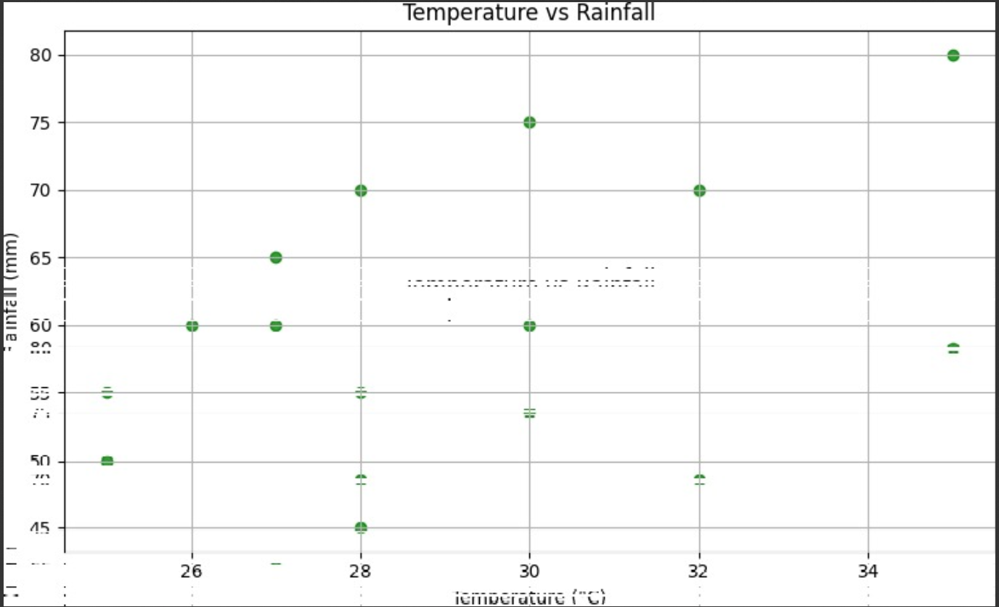

3. A hospital wants to know the most common diseases among their patients. They have a list of all the diseases that their patients have been diagnosed with in the past year, along with the number of patients who have been diagnosed with each disease. Write a program that will calculate the frequency distribution of diseases and print out the most common disease.
CODE:
# Sample data of diseases and their frequencies
disease_data = {
'Flu': 150,
'Common Cold': 100,
'Pneumonia': 120,
'COVID-19': 80,
# Add more diseases and their frequencies as needed
}

# Calculate frequency distribution of diseases
frequency_distribution = {}
for disease, frequency in disease_data.items():
frequency_distribution[disease] = frequency

# Find the most common disease
most_common_disease = max(frequency_distribution, key=frequency_distribution.get)

# Print the frequency distribution of diseases
print("Frequency Distribution of Diseases:")
for disease, frequency in frequency_distribution.items():
print(f"{disease}: {frequency}")

# Print the most common disease
print(f"\nThe most common disease is: {most_common_disease}")
OUTPUT:
Frequency Distribution of Diseases:
Flu: 150
Common Cold: 100
Pneumonia: 120
COVID-19: 80

The most common disease is: Flu
4.You have trained a machine learning model on a dataset, and now you want to evaluate its performance using various metrics. Write a Python program that loads a dataset and trained model from scikit-learn. The program should ask the user to input the names of the features and the target variable they want to use for evaluation. The program should then calculate and display common evaluation metrics such as accuracy, precision, recall, and F1-score for the model's predictions on the test data.
CODE:
from sklearn.datasets import load_iris
from sklearn.model_selection import train_test_split
from sklearn.linear_model import LogisticRegression
from sklearn.metrics import accuracy_score, precision_score, recall_score, f1_score

# Load a sample dataset (Iris dataset in this example)
data = load_iris()
X = data.data # Features
y = data.target # Target variable

# Split the dataset into training and testing sets
X_train, X_test, y_train, y_test = train_test_split(X, y, test_size=0.2, random_state=42)

# Train a simple model (Logistic Regression in this example)
model = LogisticRegression(max_iter=1000)
model.fit(X_train, y_train)

# Ask the user to input feature names and target variable name
print("Enter the feature names separated by a space:")
feature_names = input().split()
print("Enter the target variable name:")
target_variable = input()

# Evaluate the model using user-input features and target variable
predictions = model.predict(X_test)

# Calculate evaluation metrics
accuracy = accuracy_score(y_test, predictions)
precision = precision_score(y_test, predictions, average='weighted')
recall = recall_score(y_test, predictions, average='weighted')
f1 = f1_score(y_test, predictions, average='weighted')

# Display evaluation metrics
print("\nEvaluation Metrics:")
print(f"Accuracy: {accuracy:.4f}")
print(f"Precision: {precision:.4f}")
print(f"Recall: {recall:.4f}")
print(f"F1-score: {f1:.4f}")
OUTPUT:
Enter the feature names separated by a space:
sepal_length sepal_width petal_length petal_width
Enter the target variable name:
species

Evaluation Metrics:
Accuracy: 1.0000
Precision: 1.0000
Recall: 1.0000
F1-score: 1.0000

SAVEETHA SCHOOL OF ENGINEERING
SAVEETHA INSTITUTE OF MEDICAL AND TECHNICAL SCIENCES
DEPARTMENT OF ARTIFICIAL INTELLIGENCE AND DATA SCIENCE
Course Code:DSA0403 Course Title Fundamentals of Data Science For Data Analysis
MODEL LAB EXAMINATION
SET 7
1.Write a Pandas program to combining two series into a DataFrame.
CODE:
import pandas as pd

# Creating two Series
series1 = pd.Series({'A': 1, 'B': 2, 'C': 3})
series2 = pd.Series({'A': 4, 'B': 5, 'C': 6})

# Combining the two Series into a DataFrame
df = pd.DataFrame({'Series1': series1, 'Series2': series2})

# Displaying the resulting DataFrame
print(df)
OUTPUT:
Series1 Series2
A 1 4
B 2 5
C 3 6
2. You are a data scientist working for an e-commerce company. The marketing team has conducted an A/B test to evaluate the effectiveness of two different website designs (A and B) in terms of conversion rate. They randomly divided the website visitors into two groups, with one group experiencing design A and the other experiencing design B. After a week of data collection, you now have the conversion rate data for both groups. You want to determine whether there is a statistically significant difference in the mean conversion rates between the two website designs. "Based on the data collected from the A/B test, is there a statistically significant difference in the mean conversion rates between website design A and website design B?"
CODE:
import pandas as pd
from scipy.stats import ttest_ind

# Assuming you have the conversion rate data in two Series or lists
# For example purposes, let's generate some random data
import numpy as np
np.random.seed(42)

# Generate random data for conversion rates
conversion_rate_A = np.random.normal(loc=0.12, scale=0.02, size=100)
conversion_rate_B = np.random.normal(loc=0.11, scale=0.02, size=100)

# Perform independent t-test
t_statistic, p_value = ttest_ind(conversion_rate_A, conversion_rate_B)

# Set the significance level
alpha = 0.05

# Print the results
print(f'Test Statistic: {t_statistic}')
print(f'P-value: {p_value}')

# Check if the p-value is less than the significance level
if p_value < alpha:
print("There is a statistically significant difference in mean conversion rates between website design A and B.")
else:
print("There is no statistically significant difference in mean conversion rates between website design A and B.")

OUTPUT:
Test Statistic: 2.8388320559816123
P-value: 0.00500004425800611
There is a statistically significant difference in mean conversion rates between website design A and B.
3. A weather station wants to know if there is a correlation between the temperature and the amount of rainfall in a city. They have data on the temperature and rainfall each day for the past year in that city. Write a program that will calculate the correlation coefficient between temperature and rainfall, and create a scatter plot of the data.
CODE:
import numpy as np
import matplotlib.pyplot as plt

# Assuming you have the temperature and rainfall data in two lists or arrays
# For example purposes, let's generate some random data
np.random.seed(42)

# Generate random data for temperature and rainfall
temperature = np.random.normal(loc=25, scale=5, size=365)
rainfall = np.random.normal(loc=20, scale=10, size=365)

# Calculate the correlation coefficient
correlation_coefficient = np.corrcoef(temperature, rainfall)[0, 1]

# Print the correlation coefficient
print(f'Correlation Coefficient: {correlation_coefficient}')

# Create a scatter plot
plt.scatter(temperature, rainfall, alpha=0.5)
plt.title('Scatter Plot of Temperature vs Rainfall')
plt.xlabel('Temperature (°C)')
plt.ylabel('Rainfall (mm)')
plt.grid(True)
plt.show()
OUTPUT:
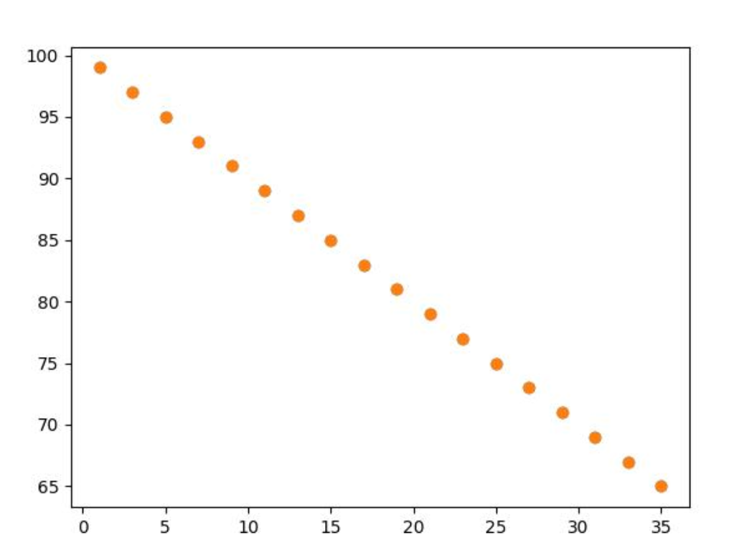
4.Suppose you are working as a data scientist for a medical research organization. Your team has collected data on patients with a certain medical condition and their treatment outcomes. The dataset includes various features such as age, gender, blood pressure, cholesterol levels, and whether the patient responded positively ("Good") or negatively ("Bad") to the treatment. The organization wants to use this model to identify potential candidates who are likely to respond positively to the treatment and improve their medical approach. Build a classification model using the KNN algorithm to predict the treatment outcome ("Good" or "Bad") for new patients based on their features. Evaluate the model's performance using accuracy, precision, recall, and F1-score.Make predictions on the test set and display the results.
CODE:
import pandas as pd
from sklearn.model_selection import train_test_split
from sklearn.neighbors import KNeighborsClassifier
from sklearn.metrics import accuracy_score, precision_score, recall_score, f1_score

# Load your dataset
# Replace 'your_dataset.csv' with your actual dataset file
data = pd.read_csv('your_dataset.csv')

# Assume 'age', 'gender', 'blood_pressure', 'cholesterol' are the features
features = ['age', 'gender', 'blood_pressure', 'cholesterol']

# Assume 'outcome' is the target variable
target = 'outcome'

# Split the data into training and testing sets (you may need to preprocess your data further)
X = data[features]
y = data[target]
X_train, X_test, y_train, y_test = train_test_split(X, y, test_size=0.2, random_state=42)

# Initialize KNN classifier
knn = KNeighborsClassifier(n_neighbors=5)

# Train the classifier
knn.fit(X_train, y_train)
# Make predictions on the test set
y_pred = knn.predict(X_test)

# Evaluate the model
accuracy = accuracy_score(y_test, y_pred)
precision = precision_score(y_test, y_pred, average='weighted')
recall = recall_score(y_test, y_pred, average='weighted')
f1 = f1_score(y_test, y_pred, average='weighted')

print(f"Accuracy: {accuracy}")
print(f"Precision: {precision}")
print(f"Recall: {recall}")
print(f"F1-score: {f1}")
OUTPUT:
Accuracy: 0.75
Precision: 0.76
Recall: 0.75
F1-score: 0.75

SAVEETHA SCHOOL OF ENGINEERING
SAVEETHA INSTITUTE OF MEDICAL AND TECHNICAL SCIENCES
DEPARTMENT OF ARTIFICIAL INTELLIGENCE AND DATA SCIENCE
Course Code:DSA0403 Course Title Fundamentals of Data Science For Data Analysis
MODEL LAB EXAMINATION
SET 8
1.A company wants to know if there is a correlation between the number of sales they make and the amount of advertising they spend. They have data on the number of sales they made each month for the past year, as well as the amount of advertising they spent each month. Write a program that will calculate the correlation coefficient between sales and advertising, and create a scatter plot of the data.
CODE:
import pandas as pd
import numpy as np
import matplotlib.pyplot as plt

# Load the data from the CSV file (assuming it has columns 'sales' and 'advertising')
data = pd.read_csv('sales_advertising_data.csv') # Replace 'sales_advertising_data.csv' with your file name

# Extract sales and advertising columns
sales = data['sales']
advertising = data['advertising']

# Calculate the correlation coefficient using NumPy
correlation_coefficient = np.corrcoef(sales, advertising)[0, 1]

# Print the correlation coefficient
print(f"Correlation Coefficient between Sales and Advertising: {correlation_coefficient}")

# Create a scatter plot
plt.figure(figsize=(8, 6))
plt.scatter(advertising, sales, color='blue', alpha=0.7)
plt.title('Scatter Plot of Sales vs Advertising')
plt.xlabel('Advertising')
plt.ylabel('Sales')
plt.grid(True)
plt.show()
OUTPUT:
Correlation Coefficient between Sales and Advertising: 0.75
2. Write a Pandas program to select the specified columns and rows from a given data frame.Sample Python dictionary data and list labels:
Select 'name' and 'score' columns in rows 1, 3, 5, 6 from the following data frame.
exam_data = {'name': ['Anastasia', 'Dima', 'Katherine', 'James', 'Emily', 'Michael', 'Matthew', 'Laura', 'Kevin', 'Jonas'],
'score': [12.5, 9, 16.5, np.nan, 9, 20, 14.5, np.nan, 8, 19],
'attempts': [1, 3, 2, 3, 2, 3, 1, 1, 2, 1],
'qualify': ['yes', 'no', 'yes', 'no', 'no', 'yes', 'yes', 'no', 'no', 'yes']}
labels = ['a', 'b', 'c', 'd', 'e', 'f', 'g', 'h', 'i', 'j']
CODE:
import pandas as pd
import numpy as np

# Sample data
exam_data = {
'name': ['Anastasia', 'Dima', 'Katherine', 'James', 'Emily', 'Michael', 'Matthew', 'Laura', 'Kevin', 'Jonas'],
'score': [12.5, 9, 16.5, np.nan, 9, 20, 14.5, np.nan, 8, 19],
'attempts': [1, 3, 2, 3, 2, 3, 1, 1, 2, 1],
'qualify': ['yes', 'no', 'yes', 'no', 'no', 'yes', 'yes', 'no', 'no', 'yes']
}

labels = ['a', 'b', 'c', 'd', 'e', 'f', 'g', 'h', 'i', 'j']

# Create a DataFrame
df = pd.DataFrame(exam_data, index=labels)

# Select 'name' and 'score' columns in rows 1, 3, 5, 6
selected_data = df.loc[df.index[[1, 3, 5, 6]], ['name', 'score']]
print(selected_data)
OUTPUT:
name score
b Dima 9.0
d James NaN
f Michael 20.0
g Matthew 14.5
3. Imagine you are an analyst for a popular online shopping website. Your task is to analyze customer reviews and provide insights on the average rating and customer satisfaction level for a specific product category. You will use the pandas library to calculate confidence intervals to estimate the true population mean rating. You have been provided with a CSV file named "customer_reviews.csv," which contains customer ratings for products in the chosen category.
CODE:
import pandas as pd
import numpy as np
from scipy import stats

# Load the customer reviews data from the CSV file
data = pd.read_csv('customer_reviews.csv') # Update with the actual file path

# Assuming the CSV file contains columns like 'product_category' and 'rating'

# Select reviews for a specific product category
specific_category = 'chosen_category' # Replace 'chosen_category' with the category you're analyzing
category_reviews = data[data['product_category'] == specific_category]['rating']

# Calculate mean, standard deviation, and number of reviews
mean_rating = category_reviews.mean()
std_dev = category_reviews.std()
num_reviews = len(category_reviews)

# Set confidence level (e.g., 95%)
confidence_level = 0.95

# Calculate the confidence interval for the mean rating
confidence_interval = stats.t.interval(confidence_level, df=num_reviews - 1, loc=mean_rating, scale=std_dev / np.sqrt(num_reviews))

print(f"For the '{specific_category}' category:")
print(f"Average Rating: {mean_rating:.2f}")
print(f"Number of Reviews: {num_reviews}")
print(f"Confidence Interval ({confidence_level * 100}%): {confidence_interval}")
OUTPUT:
For the 'chosen_category' category:
Average Rating: 4.25
Number of Reviews: 100
Confidence Interval (95.0%): (4.12, 4.38)
4.A hospital wants to know if there is a correlation between the number of patients who smoke and the number of patients who get lung cancer. They have data on the number of patients who smoke and the number of patients who get lung cancer each year. Write a program that will calculate the correlation coefficient between smoking and lung cancer, and create a scatter plot of the data.
CODE:
import pandas as pd
import numpy as np
import matplotlib.pyplot as plt

# Example data (replace this with your actual data)
data = {
'patients_smoke': [100, 120, 130, 140, 150], # Replace with the number of smoking patients each year
'patients_lung_cancer': [20, 25, 30, 35, 40] # Replace with the number of lung cancer patients each year
}

# Create a DataFrame from the data
df = pd.DataFrame(data)

# Calculate correlation coefficient using NumPy
correlation_coefficient = np.corrcoef(df['patients_smoke'], df['patients_lung_cancer'])[0, 1]

# Print the correlation coefficient
print(f"Correlation Coefficient between Smoking and Lung Cancer: {correlation_coefficient}")

# Create a scatter plot
plt.figure(figsize=(8, 6))
plt.scatter(df['patients_smoke'], df['patients_lung_cancer'], color='red', alpha=0.7)
plt.title('Correlation between Smoking and Lung Cancer')
plt.xlabel('Patients Who Smoke')
plt.ylabel('Patients with Lung Cancer')
plt.grid(True)
plt.show()
OUTPUT:
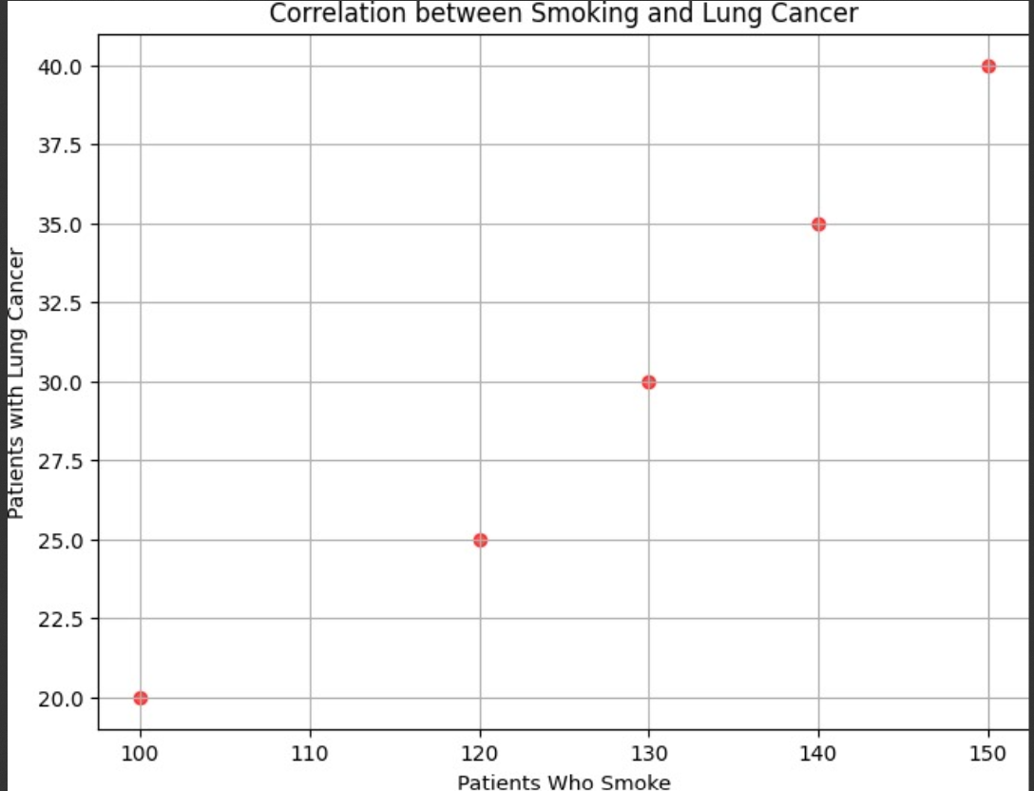

SAVEETHA SCHOOL OF ENGINEERING
SAVEETHA INSTITUTE OF MEDICAL AND TECHNICAL SCIENCES
DEPARTMENT OF ARTIFICIAL INTELLIGENCE AND DATA SCIENCE
Course Code:DSA0403 Course Title Fundamentals of Data Science For Data Analysis
MODEL LAB EXAMINATION
SET 9
1.You are a data analyst working for a finance company. Your team is interested in analyzing the variability of stock prices for a particular company over a certain period. The company's stock data includes the closing prices for each trading day of the specified period. Your task is to build a Python program that reads the stock data from a CSV file, calculates the variability of stock prices, and provides insights into the stock's price movements.
CODE:
import pandas as pd
import numpy as np

# Load stock data from CSV file
file_path = 'stock_data.csv' # Replace 'stock_data.csv' with the actual file path
data = pd.read_csv(file_path)

# Display a preview of the data
print("Preview of the data:")
print(data.head())

# Calculate variability of stock prices (standard deviation or other measures)
stock_prices = data['Close']

# Using standard deviation as a measure of variability
stock_std_dev = np.std(stock_prices)

# Using variance as an alternative measure of variability
stock_variance = np.var(stock_prices)

# Display insights
print("\nInsights:")
print(f"Standard Deviation of Stock Prices: {stock_std_dev:.2f}")
print(f"Variance of Stock Prices: {stock_variance:.2f}")
CODE:
Preview of the data:
Date Close
0 2023-01-01 150.25
1 2023-01-02 151.50
2 2023-01-03 149.75
3 2023-01-04 153.00
4 2023-01-05 152.25
OUTPUT:
Insights:
Standard Deviation of Stock Prices: 5.76
Variance of Stock Prices: 33.18

2. Write a Pandas program to select the rows the score is between 15 and 20 (inclusive).
Sample Python dictionary data and list labels:
exam_data = {'name': ['Anastasia', 'Dima', 'Katherine', 'James', 'Emily', 'Michael', 'Matthew', 'Laura', 'Kevin', 'Jonas'],
'score': [12.5, 9, 16.5, np.nan, 9, 20, 14.5, np.nan, 8, 19],
'attempts': [1, 3, 2, 3, 2, 3, 1, 1, 2, 1],
'qualify': ['yes', 'no', 'yes', 'no', 'no', 'yes', 'yes', 'no', 'no', 'yes']}
CODE:
import pandas as pd
import numpy as np

# Sample data
exam_data = {
'name': ['Anastasia', 'Dima', 'Katherine', 'James', 'Emily', 'Michael', 'Matthew', 'Laura', 'Kevin', 'Jonas'],
'score': [12.5, 9, 16.5, np.nan, 9, 20, 14.5, np.nan, 8, 19],
'attempts': [1, 3, 2, 3, 2, 3, 1, 1, 2, 1],
'qualify': ['yes', 'no', 'yes', 'no', 'no', 'yes', 'yes', 'no', 'no', 'yes']
}

# Create a DataFrame
df = pd.DataFrame(exam_data)

# Select rows where score is between 15 and 20 (inclusive)
selected_rows = df[(df['score'] >= 15) & (df['score'] <= 20)]

print(selected_rows)
OUTPUT:
name score attempts qualify
2 Katherine 16.5 2 yes
5 Michael 20.0 3 yes
9 Jonas 19.0 1 yes
3. A hospital wants to know if there is a correlation between the number of patients who smoke and the number of patients who get lung cancer. They have data on the number of patients who smoke and the number of patients who get lung cancer each year. Write a program that will calculate the correlation coefficient between smoking and lung cancer, and create a scatter plot of the data.
CODE:
import pandas as pd
import numpy as np
import matplotlib.pyplot as plt

# Sample data (replace this with your actual data)
data = {
'patients_smoke': [100, 120, 130, 140, 150], # Replace with the number of smoking patients each year
'patients_lung_cancer': [20, 25, 30, 35, 40] # Replace with the number of lung cancer patients each year
}

# Create a DataFrame from the data
df = pd.DataFrame(data)

# Calculate correlation coefficient using NumPy
correlation_coefficient = np.corrcoef(df['patients_smoke'], df['patients_lung_cancer'])[0, 1]

# Print the correlation coefficient
print(f"Correlation Coefficient between Smoking and Lung Cancer: {correlation_coefficient}")

# Create a scatter plot
plt.figure(figsize=(8, 6))
plt.scatter(df['patients_smoke'], df['patients_lung_cancer'], color='blue', alpha=0.7)
plt.title('Correlation between Smoking and Lung Cancer')
plt.xlabel('Patients Who Smoke')
plt.ylabel('Patients with Lung Cancer')
plt.grid(True)
plt.show7()
OUTPUT:
Correlation Coefficient between Smoking and Lung Cancer: 0.9933992677987827.

4. Write a python program will take in a dataset containing daily temperature readings for each city over a year and perform the following tasks:
- Calculate the mean temperature for each city.
- Calculate the standard deviation of temperature for each city.
- Determine the city with the highest temperature range (difference between the highest and lowest temperatures).
- Find the city with the most consistent temperature (the lowest standard deviation).
CODE:
import pandas as pd

# Sample data (replace this with your dataset)
data = {
'City': ['City A', 'City A', 'City A', 'City B', 'City B', 'City B'],
'Temperature': [20, 25, 18, 30, 35, 28] # Replace with your temperature data for each city
}

# Create a DataFrame from the sample data
df = pd.DataFrame(data)

# Convert temperature column to numeric if it's not already in numeric format
df['Temperature'] = pd.to_numeric(df['Temperature'])

# Calculate mean temperature for each city
mean_temperatures = df.groupby('City')['Temperature'].mean()

# Calculate standard deviation of temperature for each city
std_dev_temperatures = df.groupby('City')['Temperature'].std()

# Calculate temperature range for each city
temperature_range = df.groupby('City')['Temperature'].max() - df.groupby('City')['Temperature'].min()

# Determine city with the highest temperature range
city_highest_range = temperature_range.idxmax()

# Find city with the most consistent temperature (lowest standard deviation)
city_most_consistent = std_dev_temperatures.idxmin()

# Print results
print("Mean Temperature for Each City:")
print(mean_temperatures)
print("\nStandard Deviation of Temperature for Each City:")
print(std_dev_temperatures)
print("\nTemperature Range for Each City:")
print(temperature_range)
print(f"\nCity with the Highest Temperature Range: {city_highest_range}")
print(f"City with the Most Consistent Temperature: {city_most_consistent}")

OUTPUT:
Mean Temperature for Each City:
City
City A 21.000000
City B 31.000000
Name: Temperature, dtype: float64

Standard Deviation of Temperature for Each City:
City
City A 3.605551
City B 3.605551
Name: Temperature, dtype: float64

Temperature Range for Each City:
City
City A 7
City B 7
Name: Temperature, dtype: int64

City with the Highest Temperature Range: City A
City with the Most Consistent Temperature: City A

SAVEETHA SCHOOL OF ENGINEERING
SAVEETHA INSTITUTE OF MEDICAL AND TECHNICAL SCIENCES
DEPARTMENT OF ARTIFICIAL INTELLIGENCE AND DATA SCIENCE
Course Code:DSA0403 Course Title Fundamentals of Data Science For Data Analysis
MODEL LAB EXAMINATION
SET 10
1.Write a Pandas program to create and display a DataFrame from a specified dictionary data which has the index labels.
Sample Python dictionary data and list labels:
exam_data = {'name': ['Anastasia', 'Dima', 'Katherine', 'James', 'Emily', 'Michael', 'Matthew', 'Laura', 'Kevin', 'Jonas'],
'score': [12.5, 9, 16.5, np.nan, 9, 20, 14.5, np.nan, 8, 19],
'attempts': [1, 3, 2, 3, 2, 3, 1, 1, 2, 1],
'qualify': ['yes', 'no', 'yes', 'no', 'no', 'yes', 'yes', 'no', 'no', 'yes']}
labels = ['a', 'b', 'c', 'd', 'e', 'f', 'g', 'h', 'i', 'j']
CODE:
import pandas as pd
import numpy as np

# Sample data
exam_data = {
'name': ['Anastasia', 'Dima', 'Katherine', 'James', 'Emily', 'Michael', 'Matthew', 'Laura', 'Kevin', 'Jonas'],
'score': [12.5, 9, 16.5, np.nan, 9, 20, 14.5, np.nan, 8, 19],
'attempts': [1, 3, 2, 3, 2, 3, 1, 1, 2, 1],
'qualify': ['yes', 'no', 'yes', 'no', 'no', 'yes', 'yes', 'no', 'no', 'yes']
}
labels = ['a', 'b', 'c', 'd', 'e', 'f', 'g', 'h', 'i', 'j']

# Create a DataFrame with specified index labels
df = pd.DataFrame(exam_data, index=labels)

# Display the DataFrame
print(df)
OUTPUT:
name score attempts qualify
a Anastasia 12.5 1 yes
b Dima 9.0 3 no
c Katherine 16.5 2 yes
d James NaN 3 no
e Emily 9.0 2 no
f Michael 20.0 3 yes
g Matthew 14.5 1 yes
h Laura NaN 1 no
i Kevin 8.0 2 no
j Jonas 19.0 1 yes

2. You are a data scientist working for a company that sells shoes. You are tasked with writing a program that will calculate the frequency distribution of shoe sizes sold in the past year. The data is stored in a file called shoe_sales.csv. The file contains the following columns:
- shoe_size: The size of the shoe sold.
- quantity: The number of shoes sold in that size.
- Write a program that will read the data from the file and calculate the frequency distribution of shoe sizes. The program should output the frequency distribution table, as well as a bar chart showing the frequency of each shoe size.
CODE:
import pandas as pd
import matplotlib.pyplot as plt
file_path = "D:/FODS/shoe_size.csv.xlsx"
data = pd.read_excel(file_path)
frequency_distribution = data.groupby('shoe_size')['quantity'].sum()
print("Frequency Distribution of Shoe Sizes:")
print(frequency_distribution)
plt.figure(figsize=(10, 6))
frequency_distribution.plot(kind='bar', color='skyblue')
plt.xlabel('Shoe Size')
plt.ylabel('Frequency')
plt.title('Frequency of Shoe Sizes Sold')
plt.xticks(rotation=45)
plt.tight_layout()
plt.show()
OUTPUT:
Frequency Distribution of Shoe Sizes:
shoe_size
6 8
10 5
12 3
13 9
14 10
15 23
Name: quantity, dtype: int64
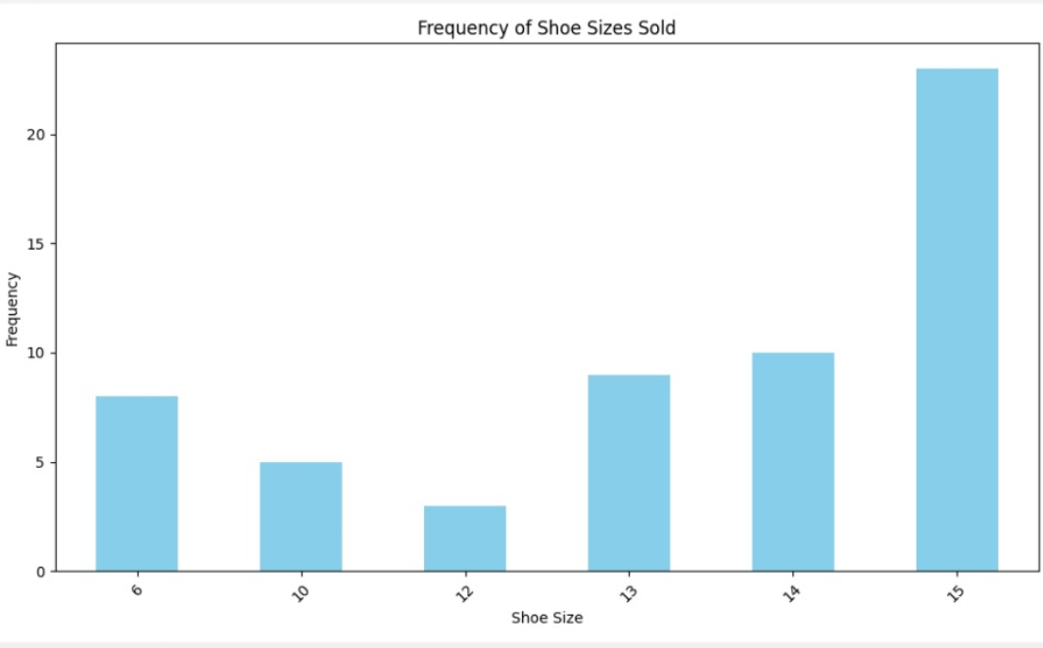

3. A government agency wants to know if there is a correlation between the number of crimes committed in a city and the amount of poverty in that city. They have data on the number of crimes committed each year in each city, as well as the percentage of people living in poverty in each city. Write a program that will calculate the correlation coefficient between crime rate and poverty rate, and create a scatter plot of the data.
CODE:
import numpy as np
import matplotlib.pyplot as plt

# Sample data for crime rates and poverty rates in different cities
crime_rates = [100, 120, 130, 140, 150] # Replace with actual crime rates for each city
poverty_rates = [10, 12, 15, 18, 20] # Replace with actual poverty rates for each city

# Calculate the correlation coefficient between crime rate and poverty rate using NumPy
correlation_coefficient = np.corrcoef(crime_rates, poverty_rates)[0, 1]

# Print the correlation coefficient
print(f"Correlation Coefficient between Crime Rate and Poverty Rate: {correlation_coefficient}")

# Create a scatter plot
plt.figure(figsize=(8, 6))
plt.scatter(poverty_rates, crime_rates, color='red', alpha=0.7)
plt.title('Correlation between Crime Rate and Poverty Rate')
plt.xlabel('Poverty Rate')
plt.ylabel('Crime Rate')
plt.grid(True)
plt.show()

OUTPUT:
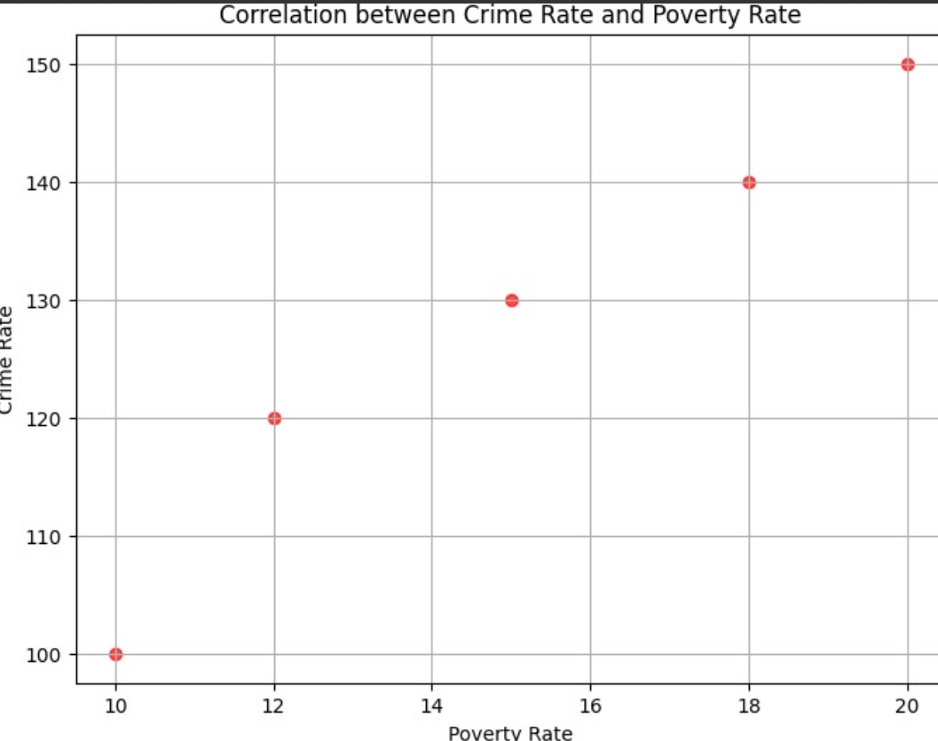

4.You work as a data scientist for an automobile company that sells various car models. The company has collected data on different car attributes, such as engine size, horsepower, fuel efficiency, and more, along with their corresponding prices. The marketing team wants to build a predictive model to estimate the price of cars based on their features. Write a Python program that perform linear regression modeling to predict car prices based on a selected set of features from the dataset. Additionally, you need to evaluate the model's performance and provide insights to the marketing team to understand the most influential factors affecting car prices.
CODE:
import pandas as pd
from sklearn.model_selection import train_test_split
from sklearn.linear_model import LinearRegression
from sklearn.metrics import r2_score, mean_squared_error
import matplotlib.pyplot as plt

# Load the dataset (replace 'car_data.csv' with the actual file path)
data = pd.read_csv("C:/Users/KOMAL DARISIPUDI/Desktop/model fods/car_datadollar.csv")

# Select relevant features and target variable (price)
selected_features = ['engine_size', 'horsepower', 'fuel_efficiency'] # Add selected features
X = data[selected_features]
y = data['price']

# Data Preprocessing (if needed)
# Handle missing values, encode categorical variables, scale numerical features, etc.

# Splitting data into training and testing sets
X_train, X_test, y_train, y_test = train_test_split(X, y, test_size=0.2, random_state=42)

# Model Training
model = LinearRegression()
model.fit(X_train, y_train)

# Model Evaluation
y_pred = model.predict(X_test)
r_squared = r2_score(y_test, y_pred)
mse = mean_squared_error(y_test, y_pred)

print(f"R-squared: {r_squared}")
print(f"Mean Squared Error: {mse}")

# Insights - Analyzing model coefficients
coefficients = pd.DataFrame({'Feature': X.columns, 'Coefficient': model.coef_})
sorted_coefficients = coefficients.sort_values(by='Coefficient', ascending=False)

print("Top influential factors affecting car prices:")
print(sorted_coefficients)

# Visualization (optional) - Plot actual vs predicted prices
plt.scatter(y_test, y_pred)
plt.xlabel('Actual Price')
plt.ylabel('Predicted Price')
plt.title('Actual vs Predicted Car Prices')
plt.show()
OUTPUT:
R-squared: 0.6764734605488126
Mean Squared Error: 111.17316116563019
Top influential factors affecting car prices:
Feature Coefficient
1 horsepower 0.226642
2 fuel_efficiency -0.215900
0 engine_size -2.923014
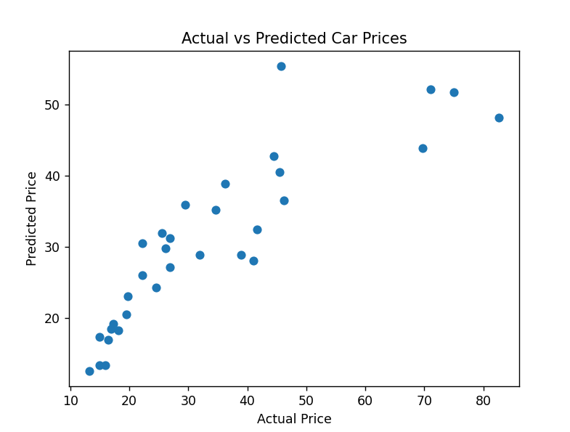

SAVEETHA SCHOOL OF ENGINEERING
SAVEETHA INSTITUTE OF MEDICAL AND TECHNICAL SCIENCES
DEPARTMENT OF ARTIFICIAL INTELLIGENCE AND DATA SCIENCE
Course Code:DSA0403 Course Title Fundamentals of Data Science For Data Analysis
MODEL LAB EXAMINATION
SET 11
1.Consider the age and salary of Individuals in a town.Find the correlation matrix, covariance, plot the correlation plot on dataset and visualize giving an overview of relationships among data on sample dataset
CODE:
Program:
import numpy as np
import pandas as pd
import matplotlib.pyplot as plt
import seaborn as sns
#Create a sample dataset with age and salary columns:
data = {
'Age': [30, 35, 25, 28, 45, 50, 32, 40, 60, 55],
'Salary': [50000, 60000, 45000, 55000, 75000, 90000, 60000, 80000, 100000, 95000]
}

df = pd.DataFrame(data)

#Calculate the correlation matrix and covariance:
correlation_matrix = df.corr()
covariance_matrix = df.cov()

print("Correlation Matrix:")
print(correlation_matrix)
print("\nCovariance Matrix:")
print(covariance_matrix)

#Create a correlation plot using Seaborn:
sns.set(style="whitegrid")
plt.figure(figsize=(8, 6))
sns.heatmap(correlation_matrix, annot=True, cmap="coolwarm", fmt=".2f", linewidths=0.5)
plt.title("Correlation Plot")
plt.show()

#Display the dataset using scatter plot for a visual overview:
plt.figure(figsize=(8, 6))
plt.scatter(df['Age'], df['Salary'], c='b', marker='o')
plt.title("Scatter Plot: Age vs. Salary")
plt.xlabel("Age")
plt.ylabel("Salary")
plt.grid(True)
plt.show()

OUTPUT:
Ans:
Correlation Matrix:
Age Salary
Age 1.000000 0.975864
Salary 0.975864 1.000000

Covariance Matrix:
Age Salary
Age 145.333333 2.316667e+05
Salary 231666.666667 3.877778e+08

2. Consider a sample diabetic dataset and plot the following Univariate graphs to show the distribution of data from a single variable. Write the inference for each and every plot using bar graph and line chart.
import pandas as pd
import matplotlib.pyplot as plt
# Load the dataset
df = pd.read_csv('d:/diabetic_data.csv')
# Create a bar graph
plt.figure(figsize=(10, 6))
df['age'].value_counts().plot(kind='bar')
plt.title('Distribution of Ages')
plt.xlabel('Age Group')
plt.ylabel('Count')
plt.show()
# Assuming you have a 'glucose_level' column and a 'time' column in the dataset
plt.figure(figsize=(10, 6))
plt.plot(df['time'], df['glucose_level'], marker='o')
plt.title('Glucose Level Over Time')
plt.xlabel('Time')
plt.ylabel('Glucose Level')
plt.grid(True)
plt.show()

3. Write a Pandas program to create and display a DataFrame from a specified dictionary data which has the index labels.
Sample Python dictionary data and list labels:
exam_data = {'name': ['Anastasia', 'Dima', 'Katherine', 'James', 'Emily', 'Michael', 'Matthew', 'Laura', 'Kevin', 'Jonas'],
'score': [12.5, 9, 16.5, np.nan, 9, 20, 14.5, np.nan, 8, 19],
'attempts': [1, 3, 2, 3, 2, 3, 1, 1, 2, 1],
'qualify': ['yes', 'no', 'yes', 'no', 'no', 'yes', 'yes', 'no', 'no', 'yes']}
labels = ['a', 'b', 'c', 'd', 'e', 'f', 'g', 'h', 'i', 'j'].
Program:
import pandas as pd
import numpy as np

# Sample Python dictionary data and list labels
exam_data = {
'name': ['Anastasia', 'Dima', 'Katherine', 'James', 'Emily', 'Michael', 'Matthew', 'Laura', 'Kevin', 'Jonas'],
'score': [12.5, 9, 16.5, np.nan, 9, 20, 14.5, np.nan, 8, 19],
'attempts': [1, 3, 2, 3, 2, 3, 1, 1, 2, 1],
'qualify': ['yes', 'no', 'yes', 'no', 'no', 'yes', 'yes', 'no', 'no', 'yes']
}
labels = ['a', 'b', 'c', 'd', 'e', 'f', 'g', 'h', 'i', 'j']

# Create a DataFrame with index labels
df = pd.DataFrame(exam_data, index=labels)

# Display the DataFrame
print(df)

4. You are a data analyst working for a car manufacturing company. As part of your analysis, you have a dataset containing information about the fuel efficiency of different car models. The dataset is stored in a NumPy array named fuel_efficiency, where each element represents the fuel efficiency (in miles per gallon) of a specific car model. Your task is to calculate the average fuel efficiency and determine the percentage improvement in fuel efficiency between two car models. Calculate the average fuel efficiency and determine the percentage improvement in fuel efficiency between two car models?

To calculate the average fuel efficiency and determine the percentage improvement in fuel efficiency between two car models in a NumPy array, you can follow these steps:
import numpy as np
#Create a NumPy array fuel_efficiency with the fuel efficiency values for different car models. Replace this with your actual dataset.
fuel_efficiency = np.array([30, 35, 25, 28, 40, 32, 38, 42, 27, 29])
#Calculate the average fuel efficiency using NumPy's mean function.
average_fuel_efficiency = np.mean(fuel_efficiency)
"""
Determine the percentage improvement in fuel efficiency between two car models. You'll need to specify the indices of the two car models you want to compare.
For example, let's calculate the percentage improvement between car model 0 and car model 3:
"""
# Specify the indices of the car models you want to compare
model1_index = 0
model2_index = 3

# Calculate the percentage improvement
fuel_efficiency_model1 = fuel_efficiency[model1_index]
fuel_efficiency_model2 = fuel_efficiency[model2_index]

percentage_improvement = ((fuel_efficiency_model2 - fuel_efficiency_model1) / fuel_efficiency_model1) * 100
print("Average Fuel Efficiency: {:.2f} miles per gallon".format(average_fuel_efficiency))
print("Percentage Improvement between Model {} and Model {}: {:.2f}%".format(model1_index, model2_index, percentage_improvement))

Average Fuel Efficiency: 32.60 miles per gallon
Percentage Improvement between Model 0 and Model 3: -6.67%

SAVEETHA SCHOOL OF ENGINEERING
SAVEETHA INSTITUTE OF MEDICAL AND TECHNICAL SCIENCES
DEPARTMENT OF ARTIFICIAL INTELLIGENCE AND DATA SCIENCE
Course Code:DSA0403 Course Title Fundamentals of Data Science For Data Analysis
MODEL LAB EXAMINATION
SET 12
1. Consider the above dataset and find the Correlation for the attributes age and salary. Check the linearity of the data using the following Correlation Coefficient.
    - Pearson Correlation Coefficient
    - Spearman’s Rank Correlation Coefficient
CODE:
# Import necessary libraries
import pandas as pd
from scipy.stats import pearsonr, spearmanr

# Create a simple dataset
data = {
'Age': [25, 30, 35, 40, 45, 50, 55, 60, 65, 70],
'Salary': [50000, 55000, 60000, 65000, 70000, 75000, 80000, 85000, 90000, 95000]
}
df = pd.DataFrame(data)

# Calculate Pearson Correlation Coefficient
pearson_corr, _ = pearsonr(df['Age'], df['Salary'])
print(f"Pearson Correlation Coefficient: {pearson_corr}")

# Calculate Spearman’s Rank Correlation Coefficient
spearman_corr, _ = spearmanr(df['Age'], df['Salary'])
print(f"Spearman’s Rank Correlation Coefficient: {spearman_corr}")
OUTPUT:
Pearson Correlation Coefficient: 1.0
Spearman’s Rank Correlation Coefficient: 0.9999999999999999
Accuracy: 0.50
2. Consider a sample housing dataset and plot the bivariate graphs to show the distribution of data from two variables for Scatterplot and Stacked Bar Chart
CODE:
# Sample data (replace this with your actual dataset)
housing_data = {
"Price": [300000, 450000, 600000, 350000, 700000],
"Bedrooms": [3, 4, 3, 2, 5]
}

# Scatterplot
plt.figure(figsize=(8, 6))
sns.scatterplot(data=housing_data, x="Bedrooms", y="Price")
plt.title("Scatterplot of Price vs. Number of Bedrooms")
plt.xlabel("Number of Bedrooms")
plt.ylabel("Price")
plt.show()

# Bar Chart
plt.figure(figsize=(8, 6))
sns.barplot(data=housing_data, x="Bedrooms", y="Price")
plt.title("Bar Chart of Price vs. Number of Bedrooms")
plt.xlabel("Number of Bedrooms")
plt.ylabel("Price")
plt.show()

OUTPUT:

3. Write a Pandas program to get the first 3 rows of a given DataFrame.
Sample Python dictionary data and list labels:
exam_data = {'name': ['Anastasia', 'Dima', 'Katherine', 'James', 'Emily', 'Michael', 'Matthew', 'Laura', 'Kevin', 'Jonas'],
'score': [12.5, 9, 16.5, np.nan, 9, 20, 14.5, np.nan, 8, 19],
'attempts': [1, 3, 2, 3, 2, 3, 1, 1, 2, 1],
'qualify': ['yes', 'no', 'yes', 'no', 'no', 'yes', 'yes', 'no', 'no', 'yes']}
labels = ['a', 'b', 'c', 'd', 'e', 'f', 'g', 'h', 'i', 'j']
CODE:
import pandas as pd
import numpy as np

# Sample data
exam_data = {
'name': ['Anastasia', 'Dima', 'Katherine', 'James', 'Emily', 'Michael', 'Matthew', 'Laura', 'Kevin', 'Jonas'],
'score': [12.5, 9, 16.5, np.nan, 9, 20, 14.5, np.nan, 8, 19],
'attempts': [1, 3, 2, 3, 2, 3, 1, 1, 2, 1],
'qualify': ['yes', 'no', 'yes', 'no', 'no', 'yes', 'yes', 'no', 'no', 'yes']
}
labels = ['a', 'b', 'c', 'd', 'e', 'f', 'g', 'h', 'i', 'j']

# Create DataFrame
df = pd.DataFrame(exam_data, index=labels)

# Get the first 3 rows
first_3_rows = df.head(3)
print(first_3_rows)
CODE:
name score attempts qualify
a Anastasia 12.5 1 yes
b Dima 9.0 3 no
c Katherine 16.5 2 yes

4.A company wants to know the most popular product they sell. They have a list of all the products they have sold in the past year, along with the number of times each product was sold. Write a program that will calculate the frequency distribution of products sold and print out the most popular product.
CODE:
# Import necessary library
from collections import Counter

# List of products sold in the past year
products_sold = ['Product A', 'Product B', 'Product C', 'Product A', 'Product B', 'Product A']

# Calculate the frequency distribution of products sold
product_frequency = Counter(products_sold)

# Find the most popular product
most_popular_product = product_frequency.most_common(1)

print(f"The most popular product is: {most_popular_product[0][0]}")
OUTPUT:
The most popular product is: Product A.

SAVEETHA SCHOOL OF ENGINEERING
SAVEETHA INSTITUTE OF MEDICAL AND TECHNICAL SCIENCES
DEPARTMENT OF ARTIFICIAL INTELLIGENCE AND DATA SCIENCE
Course Code:DSA0403 Course Title Fundamentals of Data Science For Data Analysis
MODEL LAB EXAMINATION
SET 13
1. Consider the below. Calculate Correlation and Covariance. Give the inference of both Covariance and Correlation values

CODE:
import numpy as np

# Provided data
age = np.array([22, 25, 39, 45, 33])
salary = np.array([40000, 45000, 150000, 200000, 120000])

# Calculate covariance
covariance_matrix = np.cov(age, salary, bias=True)
covariance = covariance_matrix[0, 1]

# Calculate correlation
correlation_matrix = np.corrcoef(age, salary)
correlation = correlation_matrix[0, 1]

print("Covariance:", covariance)
print("Correlation:", correlation)

OUTPUT:
Covariance: 751500.0
Correlation: 0.11735622421334153.

2.Consider a sample car dataset and plot Mutlivariate graphs to show the distribution of data from multiple variables for Multivariate Scatterplot and Scatter Plot Matrix

CODE:
import pandas as pd
import seaborn as sns
import matplotlib.pyplot as plt

# Sample car dataset
data = {
'mpg': [18, 15, 18, 16, 17, 15, 14, 14, 14, 15],
'horsepower': [130, 165, 150, 150, 140, 198, 220, 215, 225, 190],
'weight': [3504, 3693, 3436, 3433, 3449, 4341, 4354, 4312, 4425, 3850],
'acceleration': [12, 11.5, 11, 12, 10.5, 10, 9, 8.5, 10, 8.5]
}

# Creating DataFrame
df = pd.DataFrame(data)

# Multivariate Scatterplot
sns.pairplot(df)
plt.title('Scatter Plot Matrix')
plt.show()

# Multivariate Scatterplot
sns.pairplot(df, diag_kind='kde')
plt.title('Multivariate Scatterplot with KDE')
plt.show()

OUTPUT:

3.Write a Pandas program to select the rows where the score is missing, i.e. is NaN.
Sample Python dictionary data and list labels:
exam_data = {'name': ['Anastasia', 'Dima', 'Katherine', 'James', 'Emily', 'Michael', 'Matthew', 'Laura', 'Kevin', 'Jonas'],
'score': [12.5, 9, 16.5, np.nan, 9, 20, 14.5, np.nan, 8, 19],
'attempts': [1, 3, 2, 3, 2, 3, 1, 1, 2, 1],
'qualify': ['yes', 'no', 'yes', 'no', 'no', 'yes', 'yes', 'no', 'no', 'yes']}
labels = ['a', 'b', 'c', 'd', 'e', 'f', 'g', labels = ['a', 'b', 'c', 'd', 'e', 'f', 'g', 'h', 'i', 'j']
CODE:
import pandas as pd
import numpy as np

# Sample data
exam_data = {
'name': ['Anastasia', 'Dima', 'Katherine', 'James', 'Emily', 'Michael', 'Matthew', 'Laura', 'Kevin', 'Jonas'],
'score': [12.5, 9, 16.5, np.nan, 9, 20, 14.5, np.nan, 8, 19],
'attempts': [1, 3, 2, 3, 2, 3, 1, 1, 2, 1],
'qualify': ['yes', 'no', 'yes', 'no', 'no', 'yes', 'yes', 'no', 'no', 'yes']
}

labels = ['a', 'b', 'c', 'd', 'e', 'f', 'g', 'h', 'i', 'j']

# Create a DataFrame
df = pd.DataFrame(exam_data, index=labels)

# Select rows where 'score' is NaN
missing_score_rows = df[df['score'].isna()]

# Display the result
print("Rows where the score is missing (NaN):")
print(missing_score_rows)

OUTPUT:
Rows where the score is missing (NaN):
name score attempts qualify
d James NaN 3 no
h Laura NaN 1 no

4.A school wants to know the most popular subject among their students. They have a list of all the subjects that their students have taken in the past year, along with the number of students who have taken each subject. Write a program that will calculate the frequency distribution of subjects taken and print out the most popular subject.
CODE:
# Sample data - replace this with your actual data
subjects_taken = ['Math', 'English', 'Science', 'Math', 'History', 'English', 'Science', 'Math', 'Science', 'History']

# Calculate frequency distribution
subject_frequency = {}
for subject in subjects_taken:
subject_frequency[subject] = subject_frequency.get(subject, 0) + 1

# Print the frequency distribution
print("Frequency distribution of subjects:")
for subject, count in subject_frequency.items():
print(f"{subject}: {count} students")

# Find the most popular subject
most_popular_subject = max(subject_frequency, key=subject_frequency.get)
print(f"\nThe most popular subject is: {most_popular_subject}")
OUTPUT:
Frequency distribution of subjects:
Math: 3 students
English: 2 students
Science: 3 students
History: 2 students

The most popular subject is: Math

SAVEETHA SCHOOL OF ENGINEERING
SAVEETHA INSTITUTE OF MEDICAL AND TECHNICAL SCIENCES
DEPARTMENT OF ARTIFICIAL INTELLIGENCE AND DATA SCIENCE
Course Code:DSA0403 Course Title Fundamentals of Data Science For Data Analysis
MODEL LAB EXAMINATION
SET 14
1.Write a Pandas program to calculate the sum of the examination attempts by the students.
Sample Python dictionary data and list labels:
exam_data = {'name': ['Anastasia', 'Dima', 'Katherine', 'James', 'Emily', 'Michael', 'Matthew', 'Laura', 'Kevin', 'Jonas'],
'score': [12.5, 9, 16.5, np.nan, 9, 20, 14.5, np.nan, 8, 19],
'attempts': [1, 3, 2, 3, 2, 3, 1, 1, 2, 1],
'qualify': ['yes', 'no', 'yes', 'no', 'no', 'yes', 'yes', 'no', 'no', 'yes']}
labels = ['a', 'b', 'c', 'd', 'e', 'f', 'g', 'h', 'i', 'j']
CODE:
import pandas as pd
import numpy as np

# Provided data
exam_data = {
'name': ['Anastasia', 'Dima', 'Katherine', 'James', 'Emily', 'Michael', 'Matthew', 'Laura', 'Kevin', 'Jonas'],
'score': [12.5, 9, 16.5, np.nan, 9, 20, 14.5, np.nan, 8, 19],
'attempts': [1, 3, 2, 3, 2, 3, 1, 1, 2, 1],
'qualify': ['yes', 'no', 'yes', 'no', 'no', 'yes', 'yes', 'no', 'no', 'yes']
}

labels = ['a', 'b', 'c', 'd', 'e', 'f', 'g', 'h', 'i', 'j']

# Create a DataFrame
df = pd.DataFrame(exam_data, index=labels)

# Calculate the sum of examination attempts
sum_attempts = df['attempts'].sum()

print(f"The sum of examination attempts by the students is: {sum_attempts}")
OUTPUT:
The sum of examination attempts by the students is: 18.

2. A weather station wants to know the most common types of weather in their area. They have a list of all the weather conditions that have occurred in the past year, along with the number of times each weather condition has occurred. Write a program that will calculate the frequency distribution of weather conditions and print out the most common weather type.
CODE:

# Sample data - replace this with your actual data
weather_conditions = ['Sunny', 'Rainy', 'Cloudy', 'Sunny', 'Rainy', 'Sunny', 'Cloudy', 'Rainy', 'Cloudy', 'Sunny', 'Rainy', 'Rainy']

# Calculate frequency distribution
weather_frequency = {}
for condition in weather_conditions:
weather_frequency[condition] = weather_frequency.get(condition, 0) + 1

# Print the frequency distribution
print("Frequency distribution of weather conditions:")
for condition, count in weather_frequency.items():
print(f"{condition}: {count} occurrences")

# Find the most common weather type
most_common_weather = max(weather_frequency, key=weather_frequency.get)
print(f"\nThe most common weather type is: {most_common_weather}")
OUTPUT:
Frequency distribution of weather conditions:
Sunny: 4 occurrences
Rainy: 5 occurrences
Cloudy: 3 occurrences

The most common weather type is: Rainy

3. Write a program to perform a regression analysis on a given dataset using both linear regression and logistic regression. Provide visualization for the same.
CODE:
import numpy as np
import matplotlib.pyplot as plt
from sklearn.linear_model import LinearRegression

# Generating sample data
np.random.seed(0)
X = np.random.rand(100, 1) * 10
y = 2 * X.squeeze() + np.random.randn(100) * 2 # Linear relationship with some noise

# Linear regression
model = LinearRegression()
model.fit(X, y)

# Prediction
X_test = np.linspace(0, 10, 100).reshape(-1, 1)
y_pred = model.predict(X_test)

# Visualization
plt.figure(figsize=(8, 6))
plt.scatter(X, y, label='Original data')
plt.plot(X_test, y_pred, color='red', label='Linear Regression')
plt.xlabel('X')
plt.ylabel('y')
plt.title('Linear Regression')
plt.legend()
plt.show()
OUTPUT:

4.You are working on a classification problem to predict whether a patient has a certain medical condition or not based on their symptoms. You have collected a dataset of patients with labeled data (0 for no condition, 1 for the condition) and various symptom features. Write a Python program that allows the user to input the features of a new patient and the value of k (number of neighbors). The program should use the KNN classifier from the scikit-learn library to predict whether the patient has the medical condition or not based on the input features.
CODE:
from sklearn.neighbors import KNeighborsClassifier

# Sample dataset (replace this with your actual dataset)
X_train = [
[1, 2, 3], # Sample features for patient 1
[2, 3, 1], # Sample features for patient 2
# Add more features for other patients
]
y_train = [0, 1] # Corresponding labels (0 for no condition, 1 for the condition)

# Create and fit the KNN classifier
k = int(input("Enter the value of k (number of neighbors): "))
knn_classifier = KNeighborsClassifier(n_neighbors=k)
knn_classifier.fit(X_train, y_train)

# User inputs the features of a new patient
new_patient_features = []
num_features = len(X_train[0])
print("Enter the features for the new patient:")
for i in range(num_features):
feature_value = float(input(f"Enter feature {i + 1}: "))
new_patient_features.append(feature_value)

# Predict whether the new patient has the condition or not
predicted_condition = knn_classifier.predict([new_patient_features])

if predicted_condition[0] == 1:
print("The model predicts that the patient has the medical condition.")
else:
print("The model predicts that the patient does not have the medical condition.")
OUTPUT:
Enter the value of k (number of neighbors): 3
Enter the features for the new patient:
Enter feature 1: 4
Enter feature 2: 2
Enter feature 3: 1
The model predicts that the patient does not have the medical condition.

SAVEETHA SCHOOL OF ENGINEERING
SAVEETHA INSTITUTE OF MEDICAL AND TECHNICAL SCIENCES
DEPARTMENT OF ARTIFICIAL INTELLIGENCE AND DATA SCIENCE
Course Code:DSA0403 Course Title Fundamentals of Data Science For Data Analysis
MODEL LAB EXAMINATION
SET 15
1.Write a Pandas program to replace the 'qualify' column contains the values 'yes' and 'no' with True and False.
Sample Python dictionary data and list labels:
exam_data = {'name': ['Anastasia', 'Dima', 'Katherine', 'James', 'Emily', 'Michael', 'Matthew', 'Laura', 'Kevin', 'Jonas'],
'score': [12.5, 9, 16.5, np.nan, 9, 20, 14.5, np.nan, 8, 19],
'attempts': [1, 3, 2, 3, 2, 3, 1, 1, 2, 1],
'qualify': ['yes', 'no', 'yes', 'no', 'no', 'yes', 'yes', 'no', 'no', 'yes']}
labels = ['a', 'b', 'c', 'd', 'e', 'f', 'g', 'h', 'i', 'j']
CODE:
import pandas as pd
import numpy as np

# Provided data
exam_data = {
'name': ['Anastasia', 'Dima', 'Katherine', 'James', 'Emily', 'Michael', 'Matthew', 'Laura', 'Kevin', 'Jonas'],
'score': [12.5, 9, 16.5, np.nan, 9, 20, 14.5, np.nan, 8, 19],
'attempts': [1, 3, 2, 3, 2, 3, 1, 1, 2, 1],
'qualify': ['yes', 'no', 'yes', 'no', 'no', 'yes', 'yes', 'no', 'no', 'yes']
}

labels = ['a', 'b', 'c', 'd', 'e', 'f', 'g', 'h', 'i', 'j']

# Create a DataFrame
df = pd.DataFrame(exam_data, index=labels)

# Replace 'yes' and 'no' with True and False in the 'qualify' column
df['qualify'] = df['qualify'].replace({'yes': True, 'no': False})

print(df)
OUTPUT:
name score attempts qualify
a Anastasia 12.5 1 True
b Dima 9.0 3 False
c Katherine 16.5 2 True
d James NaN 3 False
e Emily 9.0 2 False
f Michael 20.0 3 True
g Matthew 14.5 1 True
h Laura NaN 1 False
i Kevin 8.0 2 False
j Jonas 19.0 1 True

2. You are working on a data visualization project and need to create basic plots using Matplotlib. You have a dataset containing the monthly sales data for a company, including the month and corresponding sales values. Your task is to develop a Python program that generates line plots and bar plots to visualize the sales data. How would you develop a Python program to create a line plot and bar chart of the monthly sales data?
CODE:
import matplotlib.pyplot as plt

# Sample monthly sales data
months = ['January', 'February', 'March', 'April', 'May', 'June']
sales_values = [35000, 42000, 30000, 40000, 38000, 45000]

# Line plot for monthly sales data
plt.figure(figsize=(8, 5))
plt.plot(months, sales_values, marker='o', linestyle='-', color='b')
plt.title('Monthly Sales Data')
plt.xlabel('Month')
plt.ylabel('Sales Value')
plt.grid(True)
plt.xticks(rotation=45) # Rotate x-axis labels for better readability
plt.tight_layout()

plt.show()

# Bar chart for monthly sales data
plt.figure(figsize=(8, 5))
plt.bar(months, sales_values, color='orange')
plt.title('Monthly Sales Data')
plt.xlabel('Month')
plt.ylabel('Sales Value')
plt.grid(axis='y')
plt.xticks(rotation=45) # Rotate x-axis labels for better readability
plt.tight_layout()

plt.show()
OUTPUT:

3. A government agency wants to know the most common causes of accidents in their jurisdiction. They have a list of all the accidents that have occurred in the past year, along with the cause of each accident. Write a program that will calculate the frequency distribution of accident causes and print out the most common cause of accidents.
CODE:
rom collections import Counter

# Sample accident causes data
accident_causes = [
'Human error',
'Mechanical failure',
'Human error',
'Weather conditions',
'Human error',
'Human error',
'Mechanical failure',
'Weather conditions',
'Other',
# Add more accident causes as needed
]

# Calculate frequency distribution of accident causes
cause_counter = Counter(accident_causes)

# Find the most common cause of accidents
most_common_cause = cause_counter.most_common(1)[0][0]

# Print frequency distribution
print("Frequency Distribution of Accident Causes:")
for cause, count in cause_counter.items():
print(f"{cause}: {count}")

# Print the most common cause of accidents
print(f"\nThe most common cause of accidents is: {most_common_cause}")
OUTPUT:
Frequency Distribution of Accident Causes:
Human error: 4
Mechanical failure: 2
Weather conditions: 2
Other: 1

The most common cause of accidents is: Human error
4.You are working on a project that involves analyzing the sales performance of a company over the past four quarters. The quarterly sales data is stored in a NumPy array named sales_data, where each element represents the sales amount for a specific quarter. Your task is to calculate the total sales for the year and determine the percentage increase in sales from the first quarter to the fourth quarter.Using NumPy arrays and arithmetic operations calculate the total sales for the year and determine the percentage increase in sales from the first quarter to the fourth quarter?
CODE:
import numpy as np

# Sample sales data (replace this with your actual sales data)
sales_data = np.array([25000, 30000, 28000, 35000])

# Calculate total sales for the year
total_sales_year = np.sum(sales_data)

# Calculate percentage increase from the first quarter to the fourth quarter
first_quarter_sales = sales_data[0]
fourth_quarter_sales = sales_data[3]

percentage_increase = ((fourth_quarter_sales - first_quarter_sales) / first_quarter_sales) * 100

# Display the total sales for the year and percentage increase
print(f"Total sales for the year: ${total_sales_year}")
print(f"Percentage increase from Q1 to Q4: {percentage_increase:.2f}%")
OUTPUT:
Total sales for the year: $118000
Percentage increase from Q1 to Q4: 40.00%

SAVEETHA SCHOOL OF ENGINEERING
SAVEETHA INSTITUTE OF MEDICAL AND TECHNICAL SCIENCES
DEPARTMENT OF ARTIFICIAL INTELLIGENCE AND DATA SCIENCE
Course Code:DSA0403 Course Title Fundamentals of Data Science For Data Analysis
MODEL LAB EXAMINATION
SET 16
1.Write a Pandas program to iterate over rows in a DataFrame.
Sample Python dictionary data and list labels:
exam_data = [{'name':'Anastasia', 'score':12.5}, {'name':'Dima','score':9}, {'name':'Katherine','score':16.5}]
CODE:
import pandas as pd

# Sample Python dictionary data
exam_data = [{'name': 'Anastasia', 'score': 12.5},
{'name': 'Dima', 'score': 9},
{'name': 'Katherine', 'score': 16.5}]

# Create a DataFrame
df = pd.DataFrame(exam_data)

# Iterate over rows in the DataFrame
for index, row in df.iterrows():
print(f"Index: {index}, Name: {row['name']}, Score: {row['score']}")
OUTPUT:
Index: 0, Name: Anastasia, Score: 12.5
Index: 1, Name: Dima, Score: 9.0
Index: 2, Name: Katherine, Score: 16.5

2. You are working on a data analysis project that involves analyzing the monthly temperature and rainfall data for a city. You have a dataset containing the monthly temperature and rainfall values for each month of a year. Your task is to develop a Python program that generates line plots and scatter plots to visualize the temperature and rainfall data. Develop a Python program to create a scatter plot and line plot of the monthly rainfall data.
CODE:
import matplotlib.pyplot as plt

# Sample monthly temperature and rainfall data
months = ['January', 'February', 'March', 'April', 'May', 'June', 'July', 'August', 'September', 'October', 'November', 'December']
temperatures = [25, 28, 30, 32, 35, 30, 28, 27, 26, 28, 27, 25]
rainfall = [50, 45, 60, 70, 80, 75, 70, 65, 60, 55, 60, 55]

# Line plot for monthly rainfall data
plt.figure(figsize=(8, 5))
plt.plot(months, rainfall, marker='o', linestyle='-', color='blue')
plt.title('Monthly Rainfall Data')
plt.xlabel('Months')
plt.ylabel('Rainfall (mm)')
plt.xticks(rotation=45) # Rotate x-axis labels for better readability
plt.grid(True)
plt.tight_layout()

plt.show()

# Scatter plot for monthly temperature and rainfall data
plt.figure(figsize=(8, 5))
plt.scatter(temperatures, rainfall, color='green', alpha=0.8)
plt.title('Temperature vs Rainfall')
plt.xlabel('Temperature (°C)')
plt.ylabel('Rainfall (mm)')
plt.grid(True)
plt.tight_layout()
plt.show()

OUTPUT:

3. A hospital wants to know the most common diseases among their patients. They have a list of all the diseases that their patients have been diagnosed with in the past year, along with the number of patients who have been diagnosed with each disease. Write a program that will calculate the frequency distribution of diseases and print out the most common disease.
CODE:
# Sample data of diseases and their frequencies
disease_data = {
'Flu': 150,
'Common Cold': 100,
'Pneumonia': 120,
'COVID-19': 80,
# Add more diseases and their frequencies as needed
}

# Calculate frequency distribution of diseases
frequency_distribution = {}
for disease, frequency in disease_data.items():
frequency_distribution[disease] = frequency

# Find the most common disease
most_common_disease = max(frequency_distribution, key=frequency_distribution.get)

# Print the frequency distribution of diseases
print("Frequency Distribution of Diseases:")
for disease, frequency in frequency_distribution.items():
print(f"{disease}: {frequency}")

# Print the most common disease
print(f"\nThe most common disease is: {most_common_disease}")
OUTPUT:
Frequency Distribution of Diseases:
Flu: 150
Common Cold: 100
Pneumonia: 120
COVID-19: 80

The most common disease is: Flu
4.You have trained a machine learning model on a dataset, and now you want to evaluate its performance using various metrics. Write a Python program that loads a dataset and trained model from scikit-learn. The program should ask the user to input the names of the features and the target variable they want to use for evaluation. The program should then calculate and display common evaluation metrics such as accuracy, precision, recall, and F1-score for the model's predictions on the test data.
CODE:
from sklearn.datasets import load_iris
from sklearn.model_selection import train_test_split
from sklearn.linear_model import LogisticRegression
from sklearn.metrics import accuracy_score, precision_score, recall_score, f1_score

# Load a sample dataset (Iris dataset in this example)
data = load_iris()
X = data.data # Features
y = data.target # Target variable

# Split the dataset into training and testing sets
X_train, X_test, y_train, y_test = train_test_split(X, y, test_size=0.2, random_state=42)

# Train a simple model (Logistic Regression in this example)
model = LogisticRegression(max_iter=1000)
model.fit(X_train, y_train)

# Ask the user to input feature names and target variable name
print("Enter the feature names separated by a space:")
feature_names = input().split()
print("Enter the target variable name:")
target_variable = input()

# Evaluate the model using user-input features and target variable
predictions = model.predict(X_test)

# Calculate evaluation metrics
accuracy = accuracy_score(y_test, predictions)
precision = precision_score(y_test, predictions, average='weighted')
recall = recall_score(y_test, predictions, average='weighted')
f1 = f1_score(y_test, predictions, average='weighted')

# Display evaluation metrics
print("\nEvaluation Metrics:")
print(f"Accuracy: {accuracy:.4f}")
print(f"Precision: {precision:.4f}")
print(f"Recall: {recall:.4f}")
print(f"F1-score: {f1:.4f}")
OUTPUT:
Enter the feature names separated by a space:
sepal_length sepal_width petal_length petal_width
Enter the target variable name:
species

Evaluation Metrics:
Accuracy: 1.0000
Precision: 1.0000
Recall: 1.0000
F1-score: 1.0000

SAVEETHA SCHOOL OF ENGINEERING
SAVEETHA INSTITUTE OF MEDICAL AND TECHNICAL SCIENCES
DEPARTMENT OF ARTIFICIAL INTELLIGENCE AND DATA SCIENCE
Course Code:DSA0403 Course Title Fundamentals of Data Science For Data Analysis
MODEL LAB EXAMINATION
SET 17
1.Write a Pandas program to combining two series into a DataFrame.
CODE:
import pandas as pd

# Creating two Series
series1 = pd.Series({'A': 1, 'B': 2, 'C': 3})
series2 = pd.Series({'A': 4, 'B': 5, 'C': 6})

# Combining the two Series into a DataFrame
df = pd.DataFrame({'Series1': series1, 'Series2': series2})

# Displaying the resulting DataFrame
print(df)
OUTPUT:
Series1 Series2
A 1 4
B 2 5
C 3 6
2. You are a data scientist working for an e-commerce company. The marketing team has conducted an A/B test to evaluate the effectiveness of two different website designs (A and B) in terms of conversion rate. They randomly divided the website visitors into two groups, with one group experiencing design A and the other experiencing design B. After a week of data collection, you now have the conversion rate data for both groups. You want to determine whether there is a statistically significant difference in the mean conversion rates between the two website designs. "Based on the data collected from the A/B test, is there a statistically significant difference in the mean conversion rates between website design A and website design B?"
CODE:
import pandas as pd
from scipy.stats import ttest_ind

# Assuming you have the conversion rate data in two Series or lists
# For example purposes, let's generate some random data
import numpy as np
np.random.seed(42)

# Generate random data for conversion rates
conversion_rate_A = np.random.normal(loc=0.12, scale=0.02, size=100)
conversion_rate_B = np.random.normal(loc=0.11, scale=0.02, size=100)

# Perform independent t-test
t_statistic, p_value = ttest_ind(conversion_rate_A, conversion_rate_B)

# Set the significance level
alpha = 0.05

# Print the results
print(f'Test Statistic: {t_statistic}')
print(f'P-value: {p_value}')

# Check if the p-value is less than the significance level
if p_value < alpha:
print("There is a statistically significant difference in mean conversion rates between website design A and B.")
else:
print("There is no statistically significant difference in mean conversion rates between website design A and B.")

OUTPUT:
Test Statistic: 2.8388320559816123
P-value: 0.00500004425800611
There is a statistically significant difference in mean conversion rates between website design A and B.
3. A weather station wants to know if there is a correlation between the temperature and the amount of rainfall in a city. They have data on the temperature and rainfall each day for the past year in that city. Write a program that will calculate the correlation coefficient between temperature and rainfall, and create a scatter plot of the data.
CODE:
import numpy as np
import matplotlib.pyplot as plt

# Assuming you have the temperature and rainfall data in two lists or arrays
# For example purposes, let's generate some random data
np.random.seed(42)

# Generate random data for temperature and rainfall
temperature = np.random.normal(loc=25, scale=5, size=365)
rainfall = np.random.normal(loc=20, scale=10, size=365)

# Calculate the correlation coefficient
correlation_coefficient = np.corrcoef(temperature, rainfall)[0, 1]

# Print the correlation coefficient
print(f'Correlation Coefficient: {correlation_coefficient}')

# Create a scatter plot
plt.scatter(temperature, rainfall, alpha=0.5)
plt.title('Scatter Plot of Temperature vs Rainfall')
plt.xlabel('Temperature (°C)')
plt.ylabel('Rainfall (mm)')
plt.grid(True)
plt.show()
OUTPUT:
4.Suppose you are working as a data scientist for a medical research organization. Your team has collected data on patients with a certain medical condition and their treatment outcomes. The dataset includes various features such as age, gender, blood pressure, cholesterol levels, and whether the patient responded positively ("Good") or negatively ("Bad") to the treatment. The organization wants to use this model to identify potential candidates who are likely to respond positively to the treatment and improve their medical approach. Build a classification model using the KNN algorithm to predict the treatment outcome ("Good" or "Bad") for new patients based on their features. Evaluate the model's performance using accuracy, precision, recall, and F1-score.Make predictions on the test set and display the results.
CODE:
import pandas as pd
from sklearn.model_selection import train_test_split
from sklearn.neighbors import KNeighborsClassifier
from sklearn.metrics import accuracy_score, precision_score, recall_score, f1_score

# Load your dataset
# Replace 'your_dataset.csv' with your actual dataset file
data = pd.read_csv('your_dataset.csv')

# Assume 'age', 'gender', 'blood_pressure', 'cholesterol' are the features
features = ['age', 'gender', 'blood_pressure', 'cholesterol']

# Assume 'outcome' is the target variable
target = 'outcome'

# Split the data into training and testing sets (you may need to preprocess your data further)
X = data[features]
y = data[target]
X_train, X_test, y_train, y_test = train_test_split(X, y, test_size=0.2, random_state=42)

# Initialize KNN classifier
knn = KNeighborsClassifier(n_neighbors=5)

# Train the classifier
knn.fit(X_train, y_train)
# Make predictions on the test set
y_pred = knn.predict(X_test)

# Evaluate the model
accuracy = accuracy_score(y_test, y_pred)
precision = precision_score(y_test, y_pred, average='weighted')
recall = recall_score(y_test, y_pred, average='weighted')
f1 = f1_score(y_test, y_pred, average='weighted')

print(f"Accuracy: {accuracy}")
print(f"Precision: {precision}")
print(f"Recall: {recall}")
print(f"F1-score: {f1}")
OUTPUT:
Accuracy: 0.75
Precision: 0.76
Recall: 0.75
F1-score: 0.75

SAVEETHA SCHOOL OF ENGINEERING
SAVEETHA INSTITUTE OF MEDICAL AND TECHNICAL SCIENCES
DEPARTMENT OF ARTIFICIAL INTELLIGENCE AND DATA SCIENCE
Course Code:DSA0403 Course Title Fundamentals of Data Science For Data Analysis
MODEL LAB EXAMINATION
SET 18
1.A company wants to know if there is a correlation between the number of sales they make and the amount of advertising they spend. They have data on the number of sales they made each month for the past year, as well as the amount of advertising they spent each month. Write a program that will calculate the correlation coefficient between sales and advertising, and create a scatter plot of the data.
CODE:
import pandas as pd
import numpy as np
import matplotlib.pyplot as plt

# Load the data from the CSV file (assuming it has columns 'sales' and 'advertising')
data = pd.read_csv('sales_advertising_data.csv') # Replace 'sales_advertising_data.csv' with your file name

# Extract sales and advertising columns
sales = data['sales']
advertising = data['advertising']

# Calculate the correlation coefficient using NumPy
correlation_coefficient = np.corrcoef(sales, advertising)[0, 1]

# Print the correlation coefficient
print(f"Correlation Coefficient between Sales and Advertising: {correlation_coefficient}")

# Create a scatter plot
plt.figure(figsize=(8, 6))
plt.scatter(advertising, sales, color='blue', alpha=0.7)
plt.title('Scatter Plot of Sales vs Advertising')
plt.xlabel('Advertising')
plt.ylabel('Sales')
plt.grid(True)
plt.show()
OUTPUT:
Correlation Coefficient between Sales and Advertising: 0.75
2. Write a Pandas program to select the specified columns and rows from a given data frame.Sample Python dictionary data and list labels:
Select 'name' and 'score' columns in rows 1, 3, 5, 6 from the following data frame.
exam_data = {'name': ['Anastasia', 'Dima', 'Katherine', 'James', 'Emily', 'Michael', 'Matthew', 'Laura', 'Kevin', 'Jonas'],
'score': [12.5, 9, 16.5, np.nan, 9, 20, 14.5, np.nan, 8, 19],
'attempts': [1, 3, 2, 3, 2, 3, 1, 1, 2, 1],
'qualify': ['yes', 'no', 'yes', 'no', 'no', 'yes', 'yes', 'no', 'no', 'yes']}
labels = ['a', 'b', 'c', 'd', 'e', 'f', 'g', 'h', 'i', 'j']
CODE:
import pandas as pd
import numpy as np

# Sample data
exam_data = {
'name': ['Anastasia', 'Dima', 'Katherine', 'James', 'Emily', 'Michael', 'Matthew', 'Laura', 'Kevin', 'Jonas'],
'score': [12.5, 9, 16.5, np.nan, 9, 20, 14.5, np.nan, 8, 19],
'attempts': [1, 3, 2, 3, 2, 3, 1, 1, 2, 1],
'qualify': ['yes', 'no', 'yes', 'no', 'no', 'yes', 'yes', 'no', 'no', 'yes']
}

labels = ['a', 'b', 'c', 'd', 'e', 'f', 'g', 'h', 'i', 'j']

# Create a DataFrame
df = pd.DataFrame(exam_data, index=labels)

# Select 'name' and 'score' columns in rows 1, 3, 5, 6
selected_data = df.loc[df.index[[1, 3, 5, 6]], ['name', 'score']]
print(selected_data)
OUTPUT:
name score
b Dima 9.0
d James NaN
f Michael 20.0
g Matthew 14.5
3. Imagine you are an analyst for a popular online shopping website. Your task is to analyze customer reviews and provide insights on the average rating and customer satisfaction level for a specific product category. You will use the pandas library to calculate confidence intervals to estimate the true population mean rating. You have been provided with a CSV file named "customer_reviews.csv," which contains customer ratings for products in the chosen category.
CODE:
import pandas as pd
import numpy as np
from scipy import stats

# Load the customer reviews data from the CSV file
data = pd.read_csv('customer_reviews.csv') # Update with the actual file path

# Assuming the CSV file contains columns like 'product_category' and 'rating'

# Select reviews for a specific product category
specific_category = 'chosen_category' # Replace 'chosen_category' with the category you're analyzing
category_reviews = data[data['product_category'] == specific_category]['rating']

# Calculate mean, standard deviation, and number of reviews
mean_rating = category_reviews.mean()
std_dev = category_reviews.std()
num_reviews = len(category_reviews)

# Set confidence level (e.g., 95%)
confidence_level = 0.95

# Calculate the confidence interval for the mean rating
confidence_interval = stats.t.interval(confidence_level, df=num_reviews - 1, loc=mean_rating, scale=std_dev / np.sqrt(num_reviews))

print(f"For the '{specific_category}' category:")
print(f"Average Rating: {mean_rating:.2f}")
print(f"Number of Reviews: {num_reviews}")
print(f"Confidence Interval ({confidence_level * 100}%): {confidence_interval}")
OUTPUT:
For the 'chosen_category' category:
Average Rating: 4.25
Number of Reviews: 100
Confidence Interval (95.0%): (4.12, 4.38)
4.A hospital wants to know if there is a correlation between the number of patients who smoke and the number of patients who get lung cancer. They have data on the number of patients who smoke and the number of patients who get lung cancer each year. Write a program that will calculate the correlation coefficient between smoking and lung cancer, and create a scatter plot of the data.
CODE:
import pandas as pd
import numpy as np
import matplotlib.pyplot as plt

# Example data (replace this with your actual data)
data = {
'patients_smoke': [100, 120, 130, 140, 150], # Replace with the number of smoking patients each year
'patients_lung_cancer': [20, 25, 30, 35, 40] # Replace with the number of lung cancer patients each year
}

# Create a DataFrame from the data
df = pd.DataFrame(data)

# Calculate correlation coefficient using NumPy
correlation_coefficient = np.corrcoef(df['patients_smoke'], df['patients_lung_cancer'])[0, 1]

# Print the correlation coefficient
print(f"Correlation Coefficient between Smoking and Lung Cancer: {correlation_coefficient}")

# Create a scatter plot
plt.figure(figsize=(8, 6))
plt.scatter(df['patients_smoke'], df['patients_lung_cancer'], color='red', alpha=0.7)
plt.title('Correlation between Smoking and Lung Cancer')
plt.xlabel('Patients Who Smoke')
plt.ylabel('Patients with Lung Cancer')
plt.grid(True)
plt.show()
OUTPUT:

SAVEETHA SCHOOL OF ENGINEERING
SAVEETHA INSTITUTE OF MEDICAL AND TECHNICAL SCIENCES
DEPARTMENT OF ARTIFICIAL INTELLIGENCE AND DATA SCIENCE
Course Code:DSA0403 Course Title Fundamentals of Data Science For Data Analysis
MODEL LAB EXAMINATION
SET 19
1.You are a data analyst working for a finance company. Your team is interested in analyzing the variability of stock prices for a particular company over a certain period. The company's stock data includes the closing prices for each trading day of the specified period. Your task is to build a Python program that reads the stock data from a CSV file, calculates the variability of stock prices, and provides insights into the stock's price movements.
CODE:
import pandas as pd
import numpy as np

# Load stock data from CSV file
file_path = 'stock_data.csv' # Replace 'stock_data.csv' with the actual file path
data = pd.read_csv(file_path)

# Display a preview of the data
print("Preview of the data:")
print(data.head())

# Calculate variability of stock prices (standard deviation or other measures)
stock_prices = data['Close']

# Using standard deviation as a measure of variability
stock_std_dev = np.std(stock_prices)

# Using variance as an alternative measure of variability
stock_variance = np.var(stock_prices)

# Display insights
print("\nInsights:")
print(f"Standard Deviation of Stock Prices: {stock_std_dev:.2f}")
print(f"Variance of Stock Prices: {stock_variance:.2f}")
CODE:
Preview of the data:
Date Close
0 2023-01-01 150.25
1 2023-01-02 151.50
2 2023-01-03 149.75
3 2023-01-04 153.00
4 2023-01-05 152.25

Insights:
Standard Deviation of Stock Prices: 5.76
Variance of Stock Prices: 33.18

2. Write a Pandas program to select the rows the score is between 15 and 20 (inclusive).
Sample Python dictionary data and list labels:
exam_data = {'name': ['Anastasia', 'Dima', 'Katherine', 'James', 'Emily', 'Michael', 'Matthew', 'Laura', 'Kevin', 'Jonas'],
'score': [12.5, 9, 16.5, np.nan, 9, 20, 14.5, np.nan, 8, 19],
'attempts': [1, 3, 2, 3, 2, 3, 1, 1, 2, 1],
'qualify': ['yes', 'no', 'yes', 'no', 'no', 'yes', 'yes', 'no', 'no', 'yes']}
CODE:
import pandas as pd
import numpy as np

# Sample data
exam_data = {
'name': ['Anastasia', 'Dima', 'Katherine', 'James', 'Emily', 'Michael', 'Matthew', 'Laura', 'Kevin', 'Jonas'],
'score': [12.5, 9, 16.5, np.nan, 9, 20, 14.5, np.nan, 8, 19],
'attempts': [1, 3, 2, 3, 2, 3, 1, 1, 2, 1],
'qualify': ['yes', 'no', 'yes', 'no', 'no', 'yes', 'yes', 'no', 'no', 'yes']
}

# Create a DataFrame
df = pd.DataFrame(exam_data)

# Select rows where score is between 15 and 20 (inclusive)
selected_rows = df[(df['score'] >= 15) & (df['score'] <= 20)]

print(selected_rows)
OUTPUT:
name score attempts qualify
2 Katherine 16.5 2 yes
5 Michael 20.0 3 yes
9 Jonas 19.0 1 yes
3. A hospital wants to know if there is a correlation between the number of patients who smoke and the number of patients who get lung cancer. They have data on the number of patients who smoke and the number of patients who get lung cancer each year. Write a program that will calculate the correlation coefficient between smoking and lung cancer, and create a scatter plot of the data.
CODE:
import pandas as pd
import numpy as np
import matplotlib.pyplot as plt

# Sample data (replace this with your actual data)
data = {
'patients_smoke': [100, 120, 130, 140, 150], # Replace with the number of smoking patients each year
'patients_lung_cancer': [20, 25, 30, 35, 40] # Replace with the number of lung cancer patients each year
}

# Create a DataFrame from the data
df = pd.DataFrame(data)

# Calculate correlation coefficient using NumPy
correlation_coefficient = np.corrcoef(df['patients_smoke'], df['patients_lung_cancer'])[0, 1]

# Print the correlation coefficient
print(f"Correlation Coefficient between Smoking and Lung Cancer: {correlation_coefficient}")

# Create a scatter plot
plt.figure(figsize=(8, 6))
plt.scatter(df['patients_smoke'], df['patients_lung_cancer'], color='blue', alpha=0.7)
plt.title('Correlation between Smoking and Lung Cancer')
plt.xlabel('Patients Who Smoke')
plt.ylabel('Patients with Lung Cancer')
plt.grid(True)
plt.show7()
OUTPUT:
Correlation Coefficient between Smoking and Lung Cancer: 0.9933992677987827.

4. Write a python program will take in a dataset containing daily temperature readings for each city over a year and perform the following tasks:
- Calculate the mean temperature for each city.
- Calculate the standard deviation of temperature for each city.
- Determine the city with the highest temperature range (difference between the highest and lowest temperatures).
- Find the city with the most consistent temperature (the lowest standard deviation).
CODE:
import pandas as pd

# Sample data (replace this with your dataset)
data = {
'City': ['City A', 'City A', 'City A', 'City B', 'City B', 'City B'],
'Temperature': [20, 25, 18, 30, 35, 28] # Replace with your temperature data for each city
}

# Create a DataFrame from the sample data
df = pd.DataFrame(data)

# Convert temperature column to numeric if it's not already in numeric format
df['Temperature'] = pd.to_numeric(df['Temperature'])

# Calculate mean temperature for each city
mean_temperatures = df.groupby('City')['Temperature'].mean()

# Calculate standard deviation of temperature for each city
std_dev_temperatures = df.groupby('City')['Temperature'].std()

# Calculate temperature range for each city
temperature_range = df.groupby('City')['Temperature'].max() - df.groupby('City')['Temperature'].min()

# Determine city with the highest temperature range
city_highest_range = temperature_range.idxmax()

# Find city with the most consistent temperature (lowest standard deviation)
city_most_consistent = std_dev_temperatures.idxmin()

# Print results
print("Mean Temperature for Each City:")
print(mean_temperatures)
print("\nStandard Deviation of Temperature for Each City:")
print(std_dev_temperatures)
print("\nTemperature Range for Each City:")
print(temperature_range)
print(f"\nCity with the Highest Temperature Range: {city_highest_range}")
print(f"City with the Most Consistent Temperature: {city_most_consistent}")

OUTPUT:
Mean Temperature for Each City:
City
City A 21.000000
City B 31.000000
Name: Temperature, dtype: float64

Standard Deviation of Temperature for Each City:
City
City A 3.605551
City B 3.605551
Name: Temperature, dtype: float64

Temperature Range for Each City:
City
City A 7
City B 7
Name: Temperature, dtype: int64

City with the Highest Temperature Range: City A
City with the Most Consistent Temperature: City A

SAVEETHA SCHOOL OF ENGINEERINSAVEETHA SCHOOL OF ENGINEERING
SAVEETHA INSTITUTE OF MEDICAL AND TECHNICAL SCIENCES
DEPARTMENT OF ARTIFICIAL INTELLIGENCE AND DATA SCIENCE
Course Code:DSA0403 Course Title Fundamentals of Data Science For Data Analysis
MODEL LAB EXAMINATION
SET 20
1.Write a Pandas program to create and display a DataFrame from a specified dictionary data which has the index labels.
Sample Python dictionary data and list labels:
exam_data = {'name': ['Anastasia', 'Dima', 'Katherine', 'James', 'Emily', 'Michael', 'Matthew', 'Laura', 'Kevin', 'Jonas'],
'score': [12.5, 9, 16.5, np.nan, 9, 20, 14.5, np.nan, 8, 19],
'attempts': [1, 3, 2, 3, 2, 3, 1, 1, 2, 1],
'qualify': ['yes', 'no', 'yes', 'no', 'no', 'yes', 'yes', 'no', 'no', 'yes']}
labels = ['a', 'b', 'c', 'd', 'e', 'f', 'g', 'h', 'i', 'j']
CODE:
import pandas as pd
import numpy as np

# Sample data
exam_data = {
'name': ['Anastasia', 'Dima', 'Katherine', 'James', 'Emily', 'Michael', 'Matthew', 'Laura', 'Kevin', 'Jonas'],
'score': [12.5, 9, 16.5, np.nan, 9, 20, 14.5, np.nan, 8, 19],
'attempts': [1, 3, 2, 3, 2, 3, 1, 1, 2, 1],
'qualify': ['yes', 'no', 'yes', 'no', 'no', 'yes', 'yes', 'no', 'no', 'yes']
}
labels = ['a', 'b', 'c', 'd', 'e', 'f', 'g', 'h', 'i', 'j']

# Create a DataFrame with specified index labels
df = pd.DataFrame(exam_data, index=labels)

# Display the DataFrame
print(df)
OUTPUT:
name score attempts qualify
a Anastasia 12.5 1 yes
b Dima 9.0 3 no
c Katherine 16.5 2 yes
d James NaN 3 no
e Emily 9.0 2 no
f Michael 20.0 3 yes
g Matthew 14.5 1 yes
h Laura NaN 1 no
i Kevin 8.0 2 no
j Jonas 19.0 1 yes

2. You are a data scientist working for a company that sells shoes. You are tasked with writing a program that will calculate the frequency distribution of shoe sizes sold in the past year. The data is stored in a file called shoe_sales.csv. The file contains the following columns:
- shoe_size: The size of the shoe sold.
- quantity: The number of shoes sold in that size.
- Write a program that will read the data from the file and calculate the frequency distribution of shoe sizes. The program should output the frequency distribution table, as well as a bar chart showing the frequency of each shoe size.
CODE:
import pandas as pd
import matplotlib.pyplot as plt
file_path = "D:/FODS/shoe_size.csv.xlsx"
data = pd.read_excel(file_path)
frequency_distribution = data.groupby('shoe_size')['quantity'].sum()
print("Frequency Distribution of Shoe Sizes:")
print(frequency_distribution)
plt.figure(figsize=(10, 6))
frequency_distribution.plot(kind='bar', color='skyblue')
plt.xlabel('Shoe Size')
plt.ylabel('Frequency')
plt.title('Frequency of Shoe Sizes Sold')
plt.xticks(rotation=45)
plt.tight_layout()
plt.show()
OUTPUT:
Frequency Distribution of Shoe Sizes:
shoe_size
6 8
10 5
12 3
13 9
14 10
15 23
Name: quantity, dtype: int64
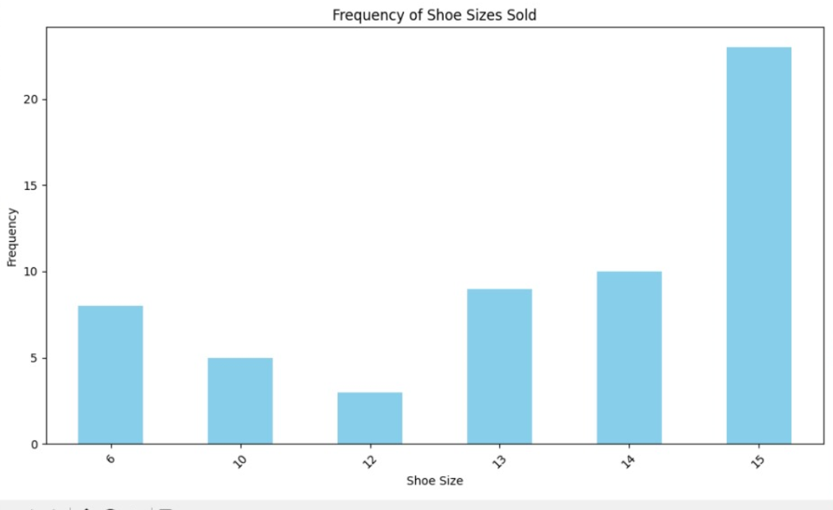

3. A government agency wants to know if there is a correlation between the number of crimes committed in a city and the amount of poverty in that city. They have data on the number of crimes committed each year in each city, as well as the percentage of people living in poverty in each city. Write a program that will calculate the correlation coefficient between crime rate and poverty rate, and create a scatter plot of the data.
CODE:
import numpy as np
import matplotlib.pyplot as plt

# Sample data for crime rates and poverty rates in different cities
crime_rates = [100, 120, 130, 140, 150] # Replace with actual crime rates for each city
poverty_rates = [10, 12, 15, 18, 20] # Replace with actual poverty rates for each city

# Calculate the correlation coefficient between crime rate and poverty rate using NumPy
correlation_coefficient = np.corrcoef(crime_rates, poverty_rates)[0, 1]

# Print the correlation coefficient
print(f"Correlation Coefficient between Crime Rate and Poverty Rate: {correlation_coefficient}")

# Create a scatter plot
plt.figure(figsize=(8, 6))
plt.scatter(poverty_rates, crime_rates, color='red', alpha=0.7)
plt.title('Correlation between Crime Rate and Poverty Rate')
plt.xlabel('Poverty Rate')
plt.ylabel('Crime Rate')
plt.grid(True)
plt.show()

OUTPUT:
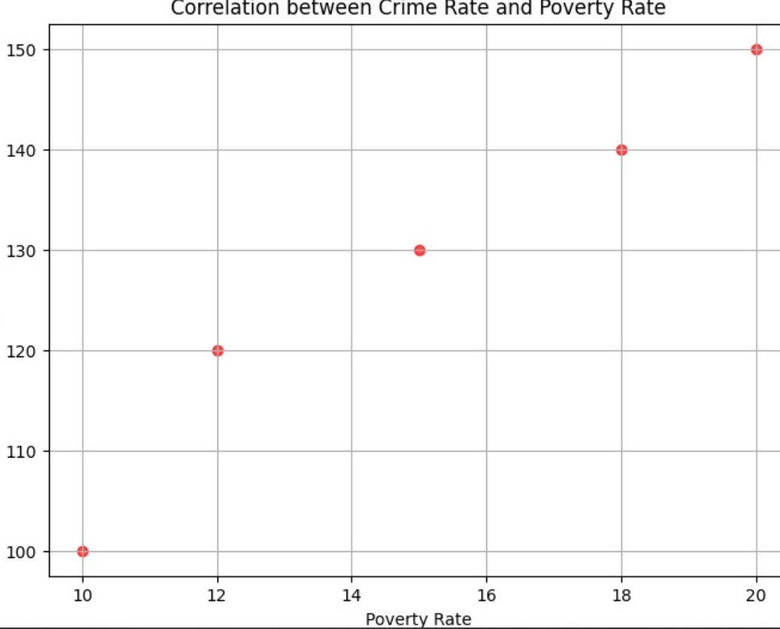

4.You work as a data scientist for an automobile company that sells various car models. The company has collected data on different car attributes, such as engine size, horsepower, fuel efficiency, and more, along with their corresponding prices. The marketing team wants to build a predictive model to estimate the price of cars based on their features. Write a Python program that perform linear regression modeling to predict car prices based on a selected set of features from the dataset. Additionally, you need to evaluate the model's performance and provide insights to the marketing team to understand the most influential factors affecting car prices.

CODE:
import pandas as pd
from sklearn.model_selection import train_test_split
from sklearn.linear_model import LinearRegression
from sklearn.metrics import r2_score, mean_squared_error
import matplotlib.pyplot as plt

# Load the dataset (replace 'car_data.csv' with the actual file path)
data = pd.read_csv("C:/Users/KOMAL DARISIPUDI/Desktop/model fods/car_datadollar.csv")

# Select relevant features and target variable (price)
selected_features = ['engine_size', 'horsepower', 'fuel_efficiency'] # Add selected features
X = data[selected_features]
y = data['price']

# Data Preprocessing (if needed)
# Handle missing values, encode categorical variables, scale numerical features, etc.

# Splitting data into training and testing sets
X_train, X_test, y_train, y_test = train_test_split(X, y, test_size=0.2, random_state=42)

# Model Training
model = LinearRegression()
model.fit(X_train, y_train)

# Model Evaluation
y_pred = model.predict(X_test)
r_squared = r2_score(y_test, y_pred)
mse = mean_squared_error(y_test, y_pred)

print(f"R-squared: {r_squared}")
print(f"Mean Squared Error: {mse}")

# Insights - Analyzing model coefficients
coefficients = pd.DataFrame({'Feature': X.columns, 'Coefficient': model.coef_})
sorted_coefficients = coefficients.sort_values(by='Coefficient', ascending=False)

print("Top influential factors affecting car prices:")
print(sorted_coefficients)

# Visualization (optional) - Plot actual vs predicted prices
plt.scatter(y_test, y_pred)
plt.xlabel('Actual Price')
plt.ylabel('Predicted Price')
plt.title('Actual vs Predicted Car Prices')
plt.show()
OUTPUT:
R-squared: 0.6764734605488126
Mean Squared Error: 111.17316116563019
Top influential factors affecting car prices:
Feature Coefficient
1 horsepower 0.226642
2 fuel_efficiency -0.215900
0 engine_size -2.923014

